Semi-quantitative petrographic characterization of Bronze Age quartzite tools – an exploratory approach

1

05 januari, 2023

Northern Fennoscandia represents a geologically complex region with both glacial and postglacial processes having an impact on the archaeology. The widely distributed moraine makes provenience studies difficult, and there is a severe lack of methodological development in the characterization of local geological materials used for tool making. The question is how to approach provenience studies in a region where there is a lack of reference samples as well as documentation of known geological sources. Quartz and quartzite are two central material types utilized among hunter-gatherers in Northern Sweden, and thus important to the understanding of raw material procurement and material flow within the region. A dataset of 445 quartz and quartzite points were analyzed non-destructively with three separate spectroscopic instrumentations, including Near-Infrared, Raman scattering and X-Ray Fluorescence. The aim was to test whether non-destructive application of these spectroscopic techniques can distinguish between different quartz and quartzite types. Multivariate modelling of the spectral data was performed using Principal Component Analysis (PCA) in which the features observed in the spectra contribute to the clustering within the model. While the results demonstrate that there are a number of structural and compositional differences within the dataset it is difficult to identify any distinct material classes based on any singular technique. The features identified do, however, provide good grounds for survey efforts and the identification of potential geological origin of some of the material. Future efforts will endeavor to model the joint relations between the separate blocks in order to test whether the combined information can aid in discerning different material classes.

1 1

Keywords: Spectroscopy; Quartzite; Characterization; Lithics

Highlights: These are the highlights.

# 1 Introduction

Petrographic characterization and provenance studies are instrumental in the modelling and inference of trade and exchange networks among prehistoric societies (REF). The presence of lithic material foreign to the local region naturally raises important questions regarding the processes that resulted in its eventual deposition and discovery. The important first step in reconstructing the *chaîne opératoire*, as well as inferences of strategies for raw material selection and management, is the characterization of the material and identifying likely geological sources. Flint and obsidian have both been central to the study of trade and exchange networks in European prehistory, due in part to the well-surveyed geological sources for these materials. The last decades, however, have seen an increase in the interest for non-flint lithics and raw material studies (Blomme et al. 2012; Dalpra and Pitblado 2016; Prieto et al. 2019; Ramacciotti et al. 2019; Prieto et al. 2020, 2021). The current bias that exists in the study of raw material management in regions where local flint and obsidian sources are non-existent[1] has been highlighted by Prieto et al. (2019, p. 15). In Northern Sweden both quartz and quartzite are instrumental in the inference of settlement and mobility within the region as they represent the most common material groups at archaeological sites. While quartz and quartzite technology have been the target of a number of studies over the years, there have been less development in the petrographic characterization and provenience studies of these same materials (Broadbent 1979; Callahan et al. 1992; Tallavaara et al. 2010; Knutsson et al. 2016). While models of raw material sourcing and trade and exchange of slate and flint within Northern Sweden has been put forth (Halén 1994, pp. 115–122; Lundberg 1997, pp. 161–171), in contrast, there has been little development on the topic of quartz and quartzite. A possible reason for this might well be the complex geological background of the region (Bargel 2003; Stroeven et al. 2016; Stephens and Bergman Weihed 2020). The abundance of moraine formations and the degree to which geological materials have been mixed and transported necessitates considerable effort in order to reconstruct the events that have formed the modern day landscape. What interpretations of lithic material sourcing within Northern Sweden there are tends to describe strategies leaning towards direct procurement from the mountain zone (Forsberg 1985, 2012). This does not, however, account for the possibility that the material was sourced locally from exposed veins in the bedrock, or as loose rocks and pebbles in the numerous moraine formations, as part of a strategy leaning more towards an embedded adaptation (Binford 1979; Rankama et al. 2006, pp. 249–250). Due to this ambiguous nature of availability of raw materials provenience studies are complex and fraught with uncertainty.

Prieto et al. (2019, p. 15; 2020, p. 32) notes that the usage of the term *quartzite* in archaeology has been somewhat ambiguous, often used interchangeably between sedimentary orthoquartzite and metamorphic quartzite. It is difficult to provide a comprehensive definition of quartzite, owing much to its metamorphic nature, and different researchers have thus emphasized different features as being characteristic of the material (Howard 2005). Visual characterization on a megascopic level is typically unreliable, and microscopic analysis is recommended for the identification of metamorphic structures, but Howard (2005, p. 708) also emphasises the need for field-based methodologies. Spectroscopic instrumentation feature fast measurements that can be collected directly on the surface of an object. With newer mobile models of these instruments readily available, this makes it an attractive option for field-based screening purposes. In the case of archaeological research it is also worth considering situations where destructive techniques, such as thin-section analysis, are not suitable or applicable. Artefact collections (museum, private, etc.) represent a valuable resource and asset, with easy access to large datasets with a wide geographical distribution. While destructive methods may prohibit access to such material there are still non-destructive alternatives that can generate valuable information. While X-Ray Fluorescence (XRF) is the go-to spectroscopic technique for petrographic characterization (Tykot 2003; Shackley 2011a), due to its capability of providing compositional data, there are other complementary instrumentations that may provide further insight into the structural properties of a material. The use of near-infrared spectroscopy (NIRS) goes almost as far back as the XRF (Norris 1996), and there is an impressive body of work dedicated to the fingerprinting of geological materials (Hunt 1977; Clark et al. 1990; Linderholm and Geladi 2014a, b; Sciuto 2018). The same can be said for Raman spectroscopy, which has been applied extensively in both the Cultural Heritage sector, in the analysis of artwork and manuscripts, as well as the Earth sciences (Dubessy et al. 2012).

In the current study a dataset of quartz and quartzite from Vilhelmina and Åsele parishes in Västerbotten, Sweden, have been analysed using the three above mentioned spectroscopic instrumentations (NIRS, Raman and XRF). The study includes points and preforms collected from 46 sites located along the Ångermanälven river valley, which runs through the western part of Västerbotten County (fig. 4.1). The aim is to assess the potential for non-destructive characterization of quartz and quartzite material without the use of references from known geological sources. The geological complexity of both the region, as well as the material, necessitates alternative approaches to studies aimed at raw material management. Without relying on well-delimited source areas for geological material, a predictive model capable of separating different “classes” of quartzite would enable spatial analysis of settlement and mobility, as well as testing of established models. The currently available data on the chemical characteristic of quartz and quartzite in this region of Northern Sweden is limited, however, and thus this study represents a first step towards developing the topic of raw material management of these materials in Northern Sweden during the 4 000 - 2 000 BP period.

# 2 Material

The current study is based on spectroscopic surface measurements collected on quartz and quartzite points recovered from excavated and surveyed sites, including stray finds, in Västerbotten County, Sweden. The sites are distributed along the Ångermanälven river valley, from the lake Kultsjön in the north, down towards the town of Åsele in the south. A dataset of 125 points, point fragments and preforms stored at the collections at Västerbotten museum (www.vbm.se) have been analysed using NIRS, Raman scattering and XRF. The material features a mainly black or gray hue, as well as a subset of semi-translucent material with a beige tint, with some being almost fully translucent. The colour of the material has been classified both according to the Munsell system, as well as sorted into general categories of hue for visualization purposes: *dark* (~ N1-N4), *light* (~ N5-N8), *white* (~ N9), and *colourless* (lack of colour, opaque to translucent).

A number of these points have, according to prior classifications, been worked using bifacial technology. While there currently is no local chronology available for this artefact type in the North Swedish region[2], there have been attempts (Forsberg 1985, p. 5, 1989; Baudou 1992, p. 99), suggesting a period of use that falls between ca. 3 800 - 2 000 BP (Käck 2009, p. 60). Similarly, studies of raw material use at sites dating to this period seems to indicate an increase in the use of quartzite when compared to prior periods (Baudou 1978).

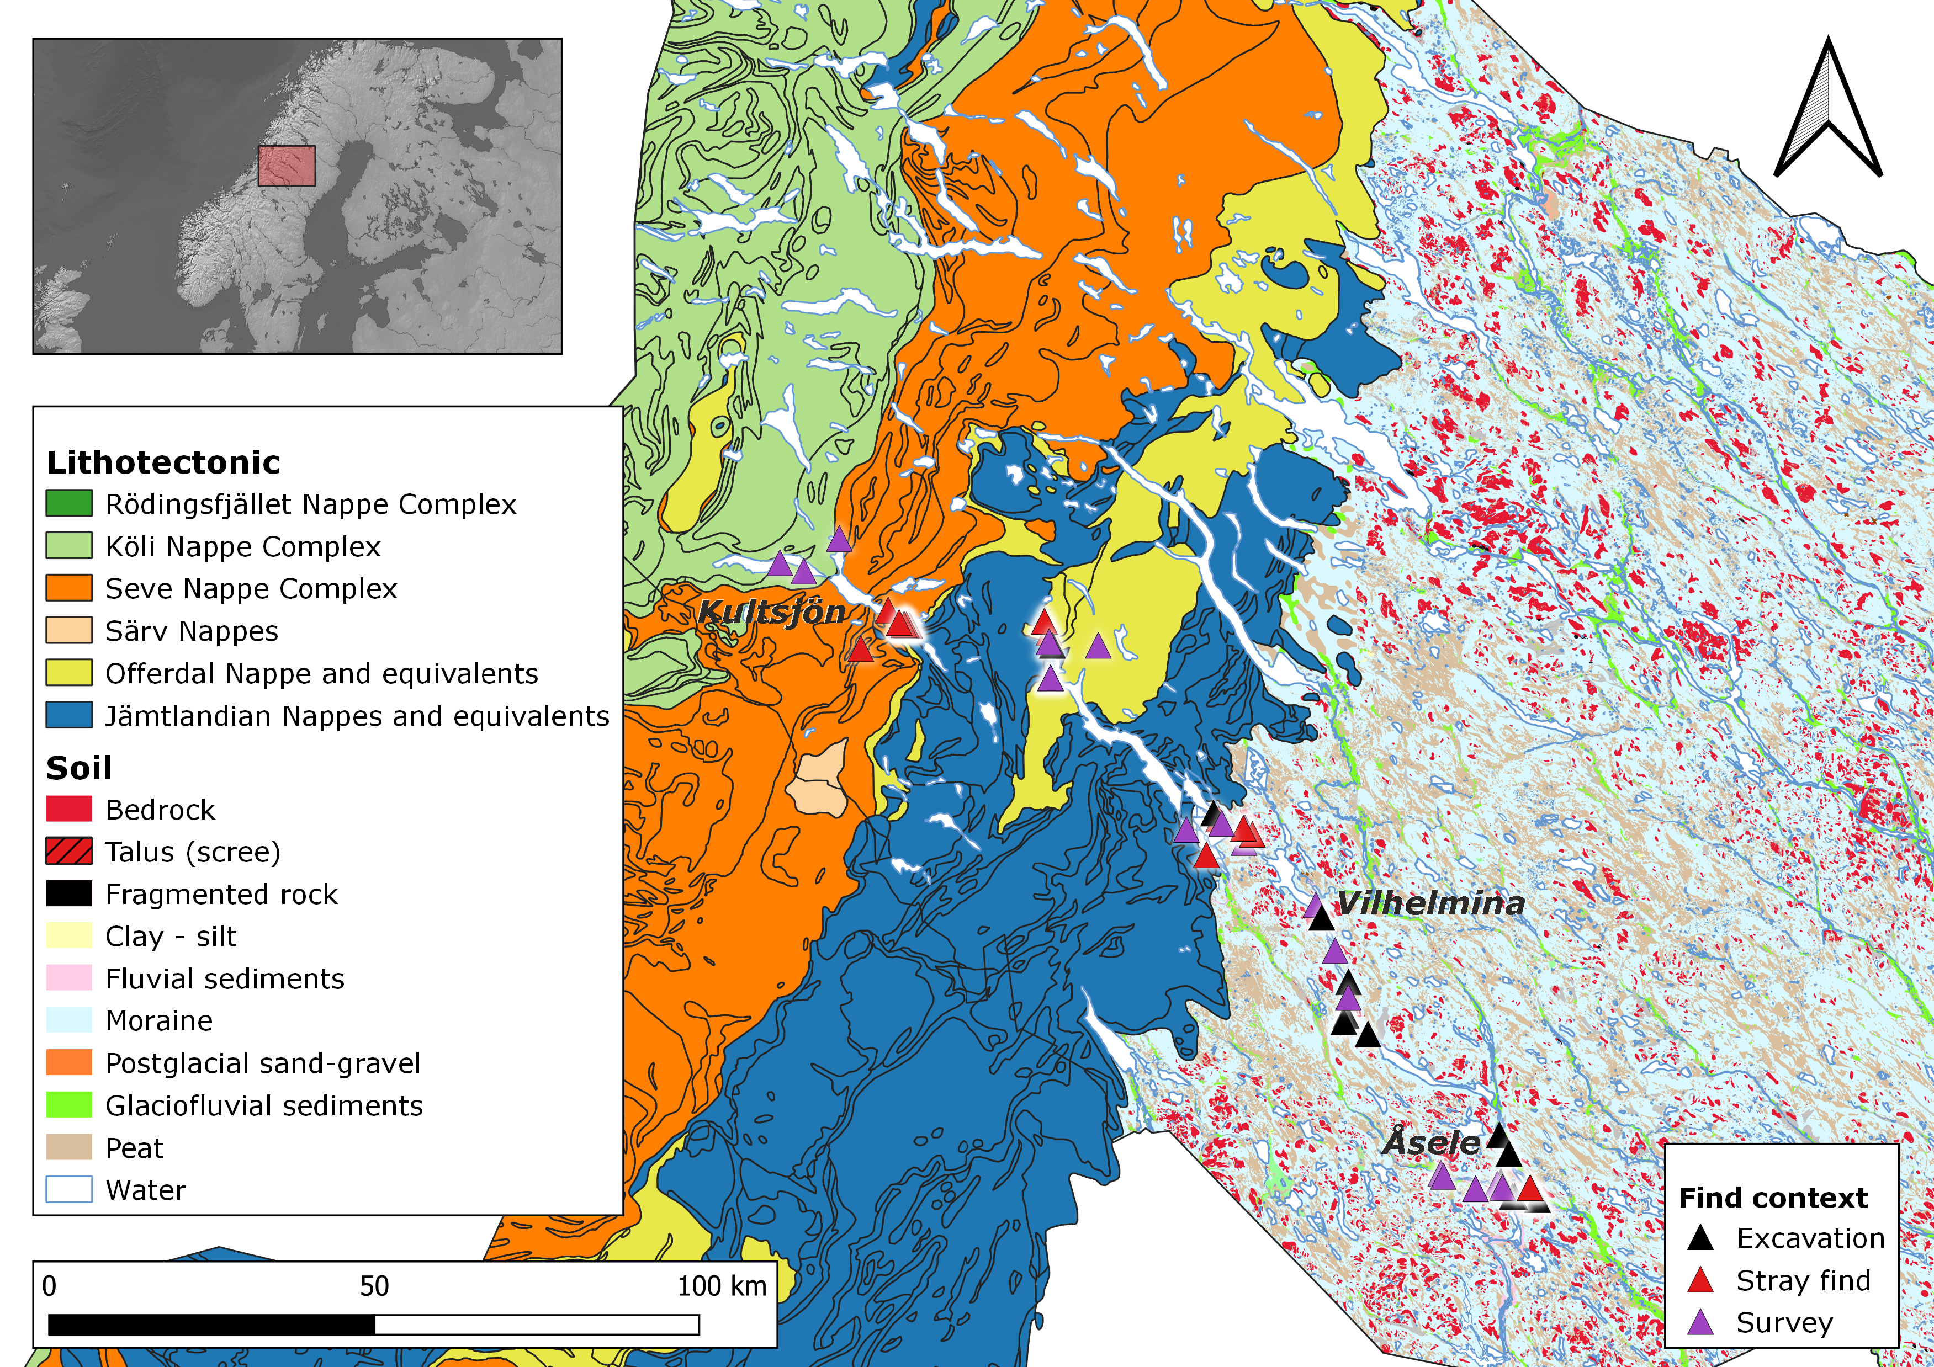

Figure 2.1: Geographical distribution of the sampled sites along the river of Ångermanälven, Västerbotten, Sweden.The glacial disturbance is visible in the widely distributd moraine. Made with ©SGU, Lantmäteriet (CC0), Natural Earth, and Riksantikvarieämbetet.

The dataset includes three main groups of registered petrographic material: quartz, quartzite, and brecciated quartz (Swe. “*brecciekvarts*”). Those that had no prior classification available were sorted into either the quartz or quartzite category based on visual inspection. This resulted in: 4 brecciated quartz samples, 2 quartz samples, and 119 quartzite samples. The inclusion of quartz and brecciated quartz in the study serves two purposes. The first being to test the potential for the instrumentation to separate quartz from quartzite based on their chemical and structural characteristic, and the second related purpose is to account for potential mistakes in the original classification.

When analysing the lithic material from the *Early Norrland* project (Åhman 1967; Biörnstad 1968), the geologist Åhman (1967, p. 8) introduced the term *brecciated quartz* (also referred to as *mylonite quartz*) to archaeologists in Northern Sweden. Åhman describes the material as easily mistaken for an unusually pure quartzite, however, the fragmented configuration of quartz can be identified via microscopic analysis. *Brecciated quartz* in particular became a somewhat common term used in North Swedish archaeology, and has typically been used to identify a certain translucent type of fine-grained, quartz-rich material (e.g. Holm 1991, p. 24). As the material frequently has been characterized based on megascopic characteristics, despite the central features necessary for characterization being microscopic, there is value in including a test group in the study.

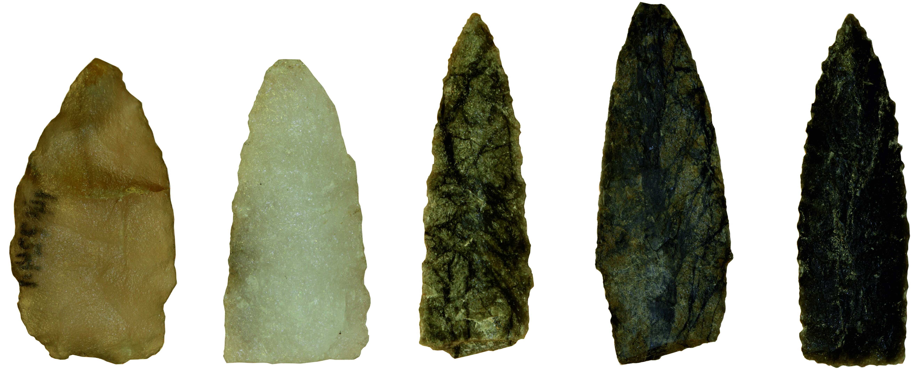

Figure 2.2: An assortment of points demonstrating the variation in color and heterogeneity of the material.

# 3 Methods

All measurements were performed at the Environmental Archaeology Lab at Umeå University[3]. The analysis was conducted in a dark room in order to minimize light pollution, with the main light sources in the room being the computer screens. Each artefact was sampled twice, on different sides, with additional measurements in cases where sampling was difficult. For materials that featured high heterogeneity the sample point was focused, as much as possible, on the surrounding matrix. An exception had to be made in the case of the XRF, however, where due to time constraints one measurement was collected as a rule apart from a few exceptions. This lowers the statistical reliability of the XRF analysis and inferences of the results should be evaluated with this in mind. The size of the dataset alleviates some of these issues, as for the larger sites there are multiple objects that may come from the same geological source, but the same can not be said for sites with smaller assemblages.

Data analysis and visualisation was performed in R (R Core Team 2021a) using a suite of packages, including Chemospec (Hanson 2016) and zCompositions (Palarea-Albaladejo and Martin-Fernandez 2015) for data processing, and ggplot2 (Wickham 2016) for visualisation. Pre-processing and analysis of the data is different for each instrumentation and based on relevant literature. Data exploration and analysis was performed using Principal Component Analysis (PCA).

## 3.1 Instrumentaion and pre-processing

### 3.1.1 Near Infrared

NIRS measures the absorbance of light within the near infrared region (780 nm – 2 500 nm) of the electromagnetic spectrum. Based on the theory of molecular vibration and excitation (Hunt 1977), by exposing a geological material to electromagnetic radiation it is possible to generate overtone vibrations which can be related to certain molecular groups. The most common group capable of generating these overtones is the OH group, which in quartz-based materials typically relates to molecular water and metal-OH combinations (Hunt 1977, p. 508).

NIR analysis was conducted with the Analytical Spectral Device (ASD) LabSpec 4, using a contact probe. The ASD features a detection range of 350 nm – 2 500 nm, with spectral sampling (resp. spectral resolution) of 1.4 nm (resp. 3 nm) in the visible and near infrared range and 1.1 nm (resp. 10 nm) in the short‐wave infrared range. Each object was measured against a white reference background and the collected measurements were averaged for each artefact. The data was restricted to the 1 000 nm - 2 500 nm range and mean-centred before PCA modelling.

### 3.1.2 Raman

Raman spectroscopy shares some similarities with NIRS in that they both can be used to infer molecular structure based on their vibrational properties within the near-infrared spectrum (Nafie 2001). However, where NIRS measures light absorbance and generate overtones of molecular vibration, Raman spectroscopy is based on the *Raman scattering* effect. By exposing a molecule to radiation with a monochromatic laser it is possible to induce a dipole moment in the molecule which generates the Raman effect. The subsequent light that is scattered contains both Rayleigh and Raman scatter, the former at a frequency of incident radiation and the latter at a shifted frequency (Dubessy et al. 2012). The spectrometer will measure the Raman scatter and generate a spectrum where the spectral line has shifted compared to the incident Rayleigh frequency. As the structure of a molecule will inform its vibrational mode, the point at which these shifts occur within the infrared region varies depending on the material (Smith and Carabatos-Nédelec 2001).

The Raman instrumentation used was a portable i-Raman EX featuring a 1064 nm excitation laser. The spectral coverage of the instrumentation is 175 cm-1 – 2 500 cm-1 [4] with a resolution of 9.5 cm-1. Access to the spectrometer was made possible by the department of Forest Biomaterials and Technology at the Swedish University of Agricultural Sciences (SLU) in Umeå[5].

After averaging the spectra for each artefact the results were baseline corrected in order to detrend the data. This was achieved using modified polynomial fitting (Lieber and Mahadevan-Jansen 2003) from the ChemoSpec package (Hanson 2016). The spectra were then mean-centred before PCA.

### 3.1.3 X-Ray Fluourescence

XRF spectroscopy, and its capabilities for quantifying chemical elements in different materials, has made it a well-established method in petrographic characterization in archaeology (Hall 1960; Shackley 2011a). Exposing a material to X-ray radiation causes electrons to dislodge and move between the electron shells of the atoms, which in turn emits energy (i.e. *fluourescence*). As the energy differences between electron shells for the various elements is known it is possible to both identify and quantify the abundance of an element (Shackley 2011b, p. 16), which is useful for provenience studies where the chemical character of an unknown and a reference sample can be tested statistically (Tykot 2003).

XRF measurements were collected using a Thermo Scientific Niton XL5 Analyzer, connected to a portable test stand. The reference calibration used for element quantification was set to *mining* mode (Knight et al. 2021, p. 2). The integration time was set to 130 seconds in order for the instrument to cycle through all of the filters (main, low, high, light). Due to time constraints, and the number of objects included in the project, it was only possible to sample each object once, apart from some exceptions.

Before engagaging in any analysis it is important to address the *closed sum* effect of compositional data (Pawlowsky-Glahn and Egozcue 2006). As the variables are given as proportions of a constant sum (e.g. percentage, parts per million) this means that if one element was to change in value, others would follow (Grunsky and Caritat 2020). This is managed by transforming the data using log-ratio transformation (Aitchison 1999), and currently there are three main methods for achieving this; additive log-ratio (alr), centered log-ratio (clr) or isometric log-ratio. They all have their own nuances and as such the choice of method is dependent on the type of analysis and material (Pawlowsky-Glahn et al. 2015). In the PCA the Principal Components are orthonormal, and thus the relationships between variables treated with log-ratio transformation are linear and independent of the total concentration (e.g. Reimann et al. 2012). This makes multivariate methods like PCA suitable for identifying geochemical trends related to the rock-forming process.

As the current dataset features values below the Limit of Detection (LOD) these were treated as NULL (or “missing values”) during PCA. A LOD value is defined as a measured value 3 times lower than the standard deviation for that measurement. Since missing values are not permitted during PCA these had to be imputed before the analysis, which was performed using the *lrEM* function from the *zCompositions* R package (Palarea-Albaladejo and Martin-Fernandez 2015). *lrEM* stands for “Log-ratio Expectation-Maximisation”, which is an algorithm used to impute “left-censored data” (e.g. values below LOD, rounded zeros). Following log-transformation the data was then mean-centered and scaled to unit variance before PCA.

## 3.2 PCA

The data was evaluated using PCA, which is an unsupervised exploratory technique to reduce the dimensionality of a dataset (Geladi and Linderholm 2020). Multivariate approaches, such as PCA, has proven useful for exploring complex spectroscopic datasets (Sciuto 2018). Clusters and trends that emerge in the resulting score plot can potentially be related to the spectral fingerprints of the material. These groupings can then be followed up with supervised methods, and aid in the construction of predicitive models.

PCA analysis was performed using the base R *prcomp()* function (R Core Team 2021a, b).

# 4 Results

## 4.1 NIR - near infrared range

It is well-known that NIRS is less effective on translucent material, such as a pure quartz crystal, as the absence of impurities in the material will result in little to no reflection/absorbance of light (Hunt 1977). Similarly it can be difficult to work with dark materials as most of the light produced by the instrument will be absorbed, with the high absorbance potentially obscuring visible features in the spectra. This effect can be seen in figure 4.1 which shows a summary of the centered NIR spectra by color group. Apart from the dark material featuring a wider range of absorbance, likely owing some to the range of hues within the group, they generally features less distinct peaks than the material with a lighter hue. This is not to say that all spectra collected on dark quartzite features less information, but any model including them will likely affect the clustering of the dataset as a whole.

The spectra were evaluated using using Savitzky-Golay (SG) filtering, a smoothing technique widely applied in spectroscopy (Chryssikos and Gates 2017, pp. 78–81). 2nd derivative SG can amplify weaker peaks in the spectra, although at the cost of potentially amplifying noise (Mark and Workman 2021, pp. 351–397; Schmid et al. 2022). An example of this can be seen in fig. 4.2, where the spectra from two different dark objects are compared. The non-processed spectra are fairly indistinct, but the derivative transformation of sample 258 amplifies a number of significant peaks. The derivative spectra of sample 411, however, does not have as clear and distinct peaks and features mainly noise. In both cases an interesting feature at 1 800 nm have also been amplified, which happens to be a filter shift in the instrumentation. After reviewing the dark spectra, out of a total of 92, 45 were kept in the dark group.

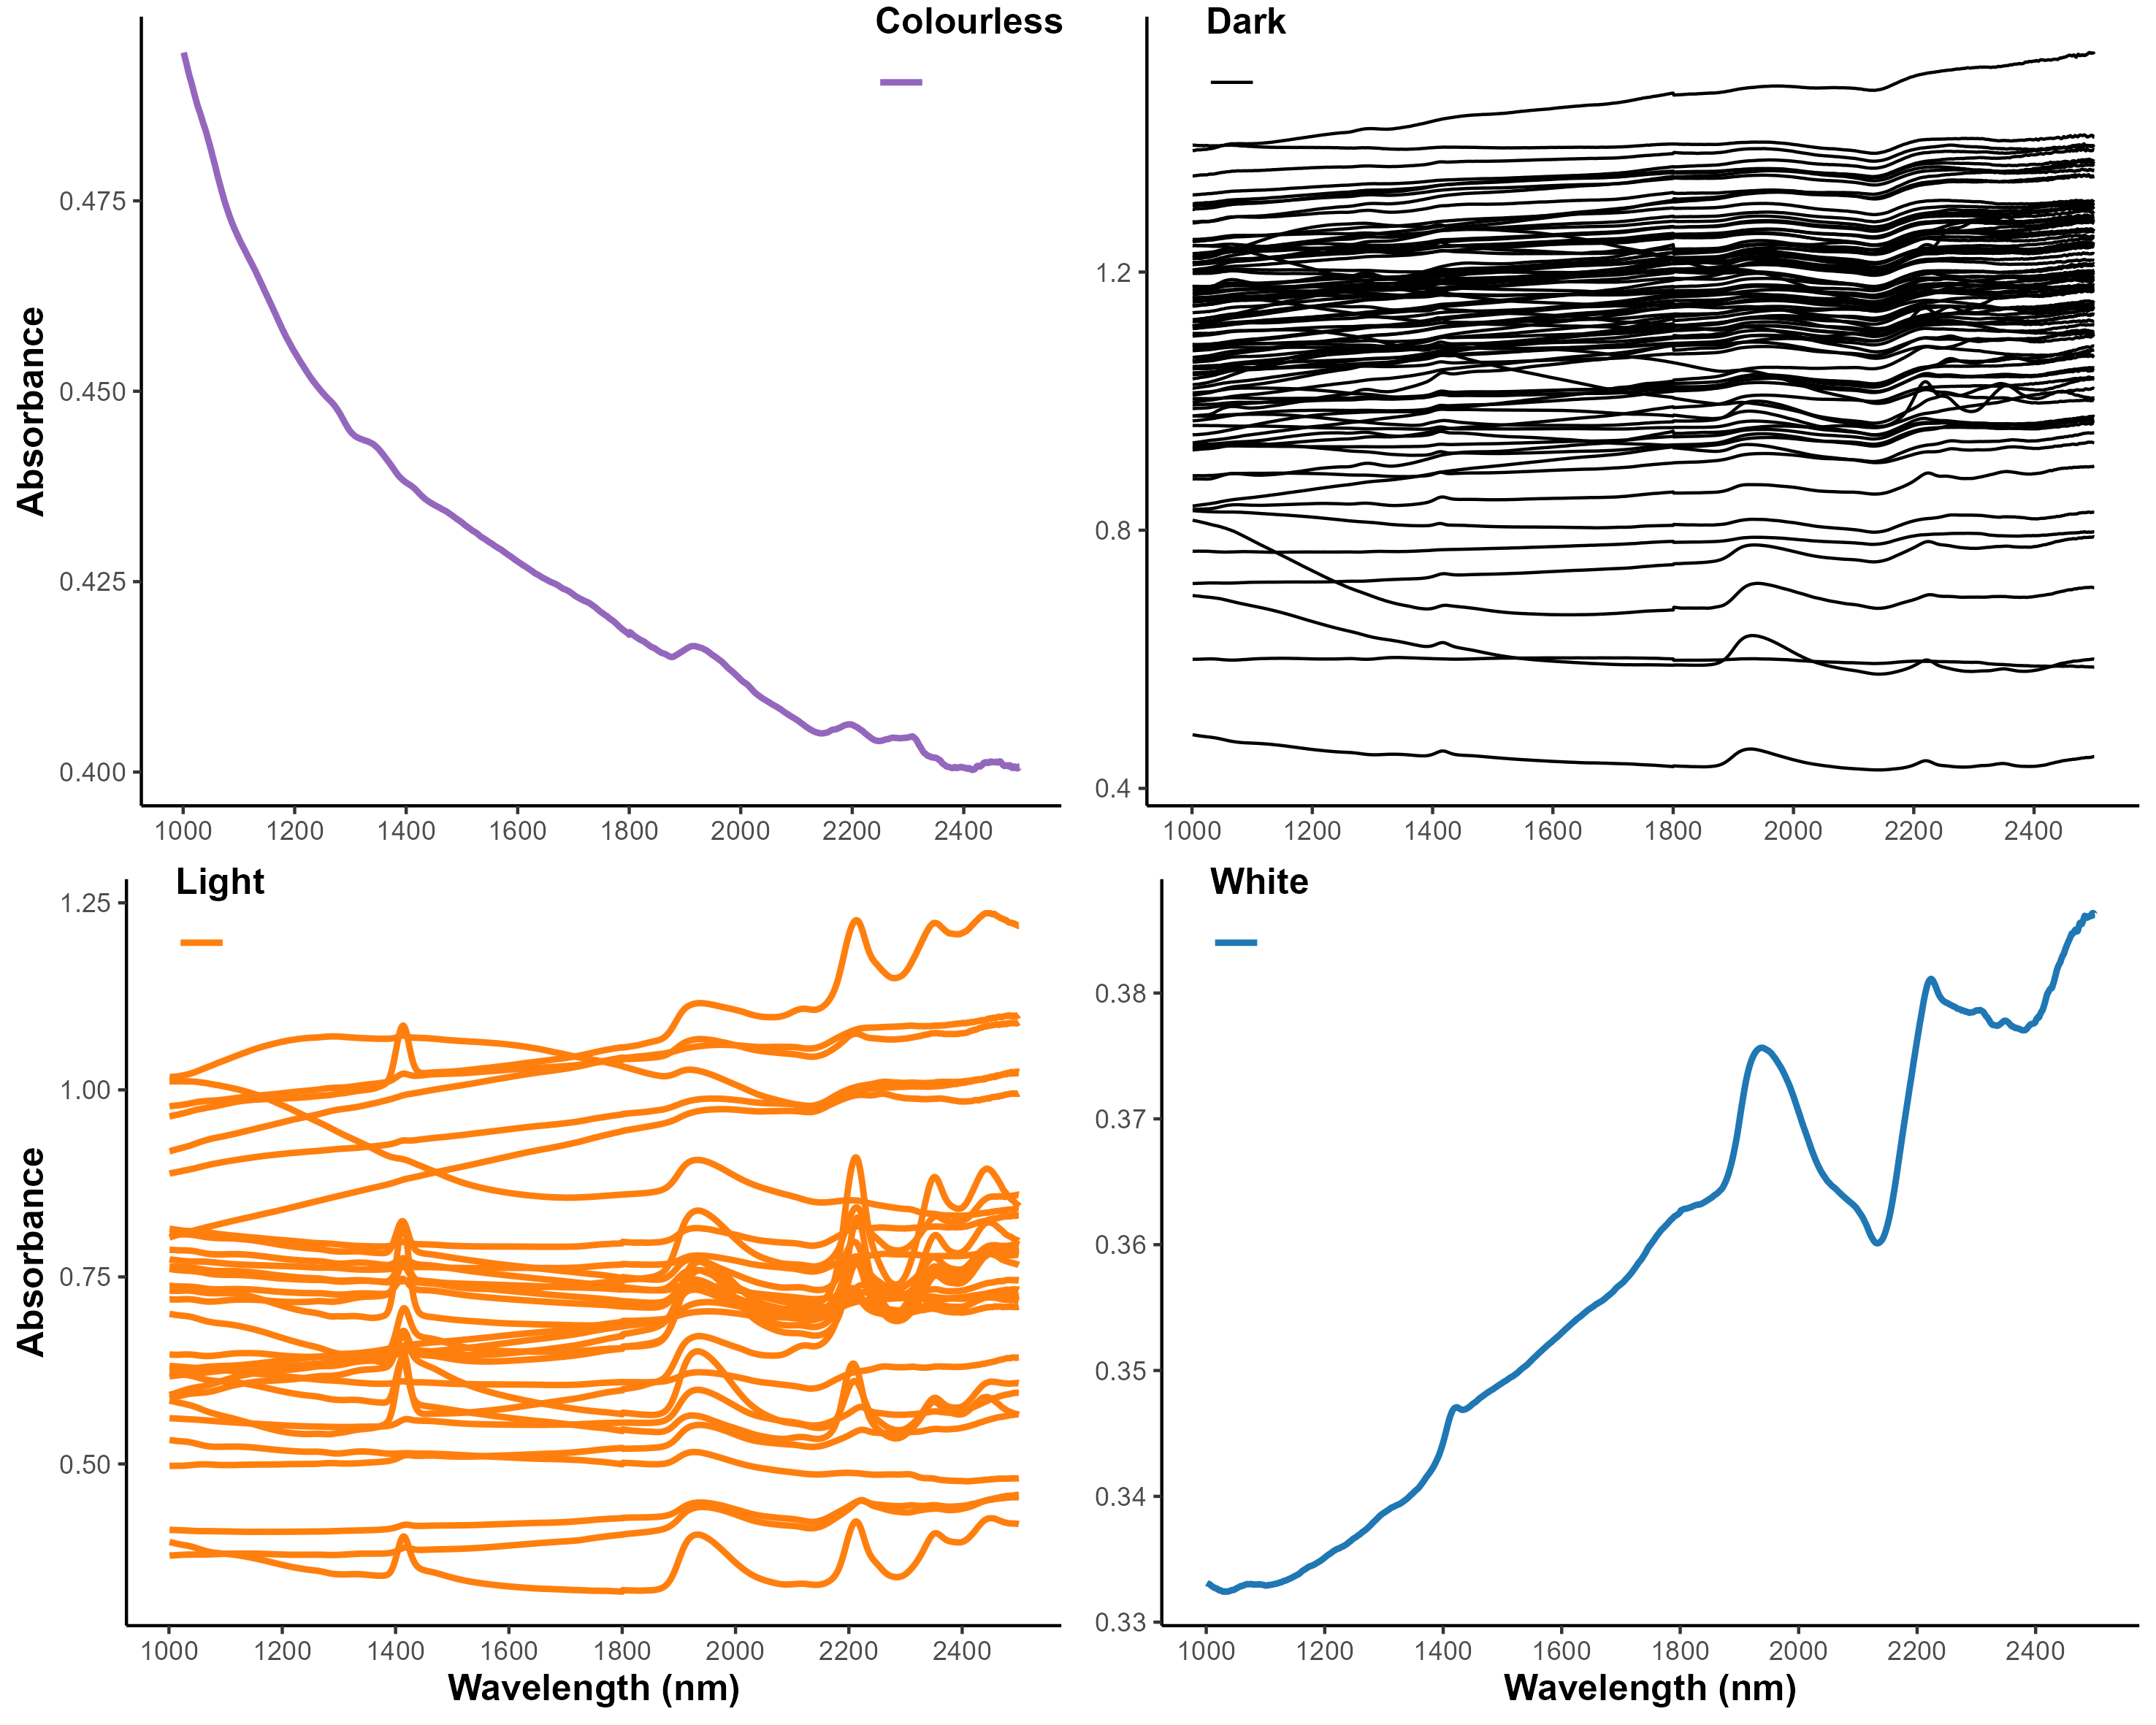

Figure 4.1: Summary of the raw spectra for each colour group. Note the differences in absorbance between the groups, with the dark group featuring a larger range of absorbance values as well as less distinct peaks.

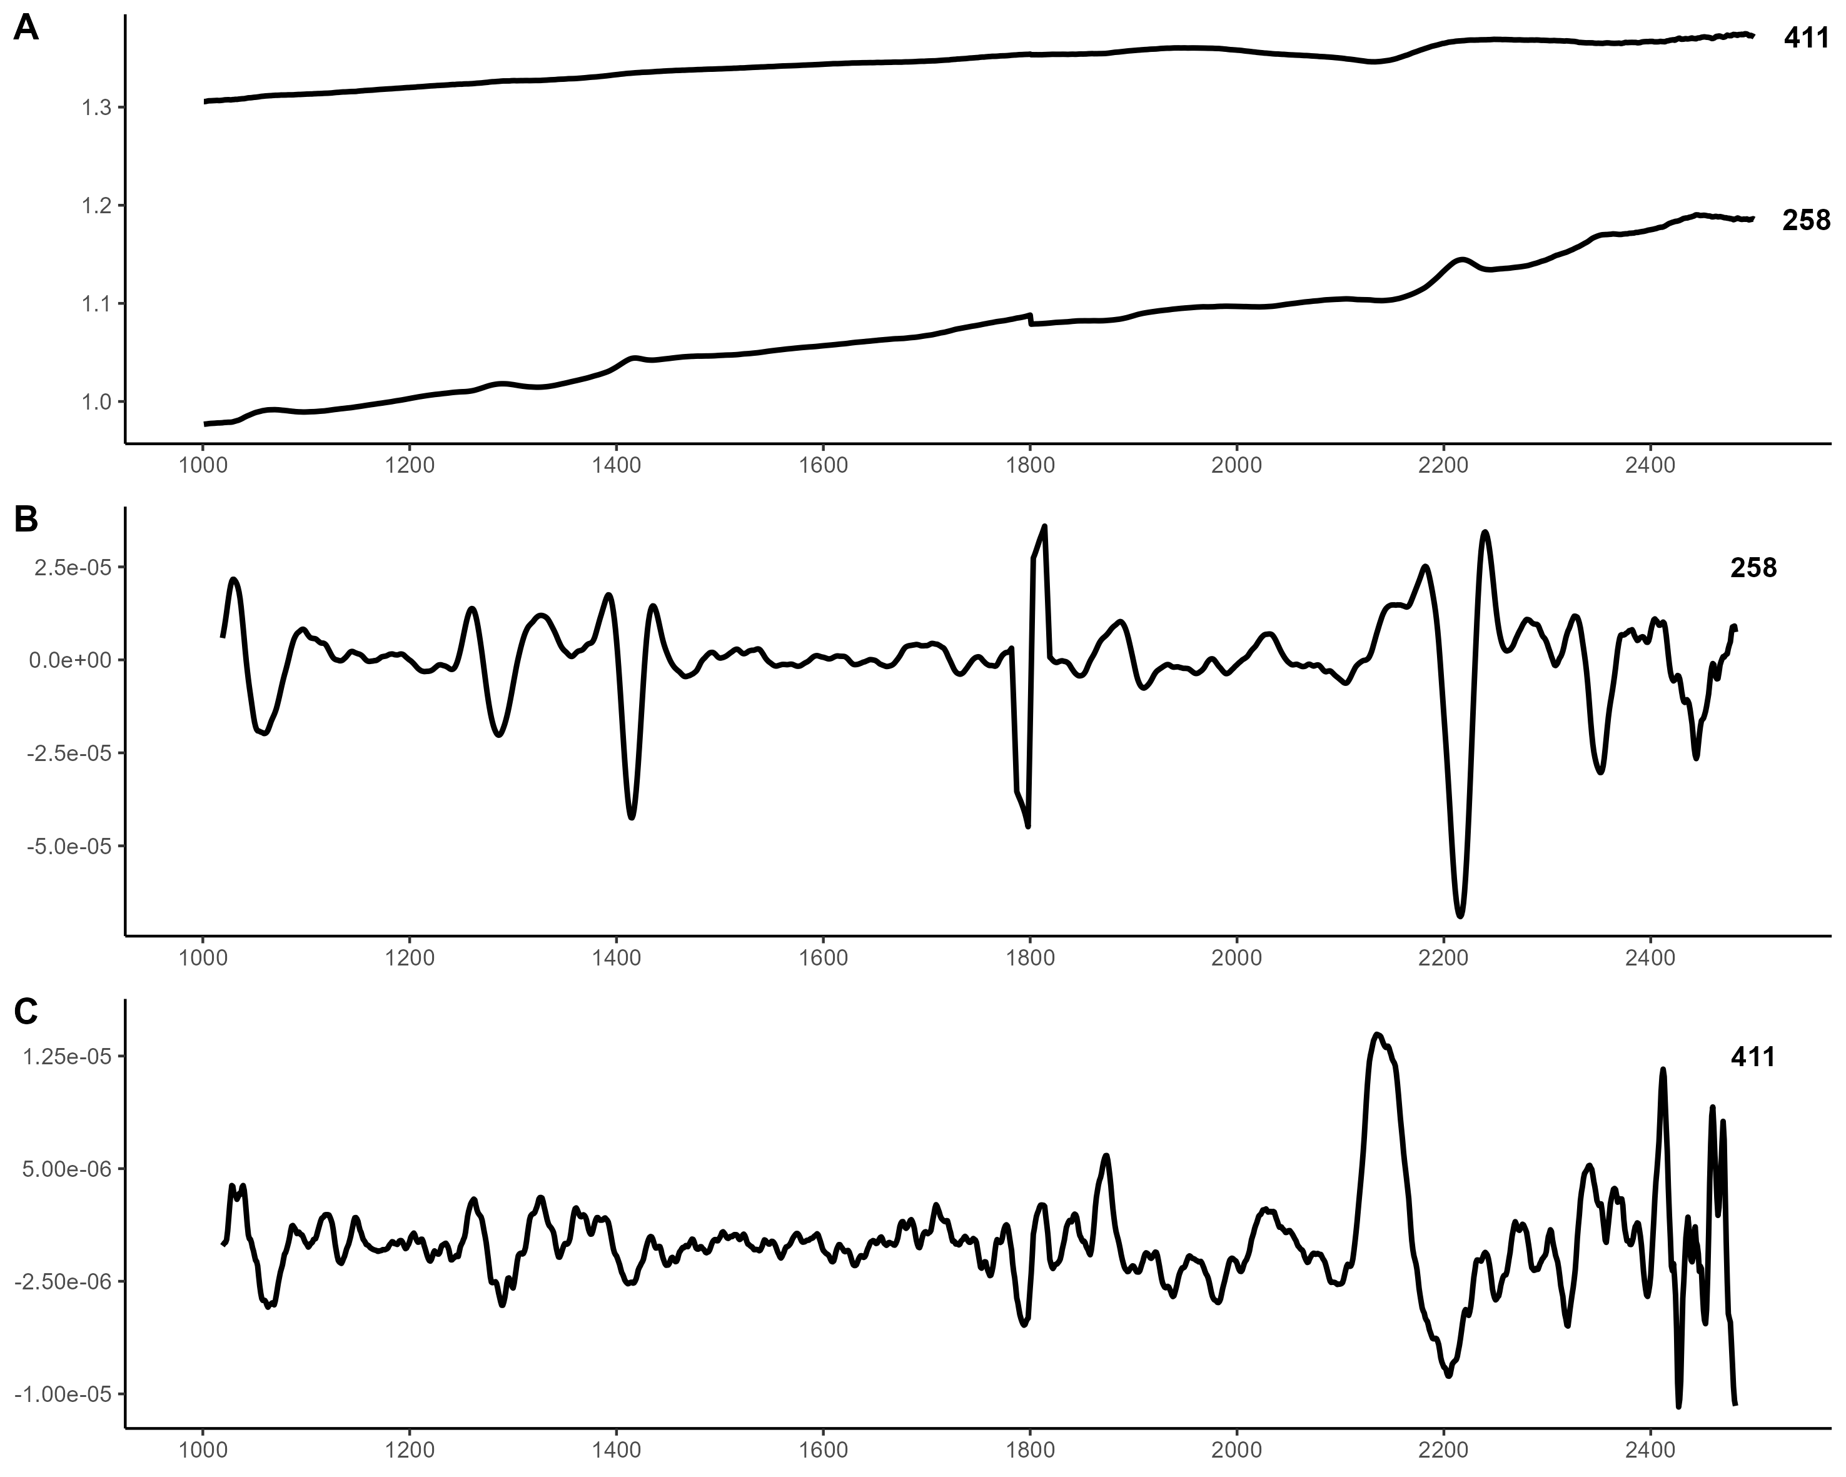

Figure 4.2: Comparison of NIR spectra between two samples from the dark group. a) the non-processed spectra for sample 258 and 411, b) sample 258 spectra with 2nd derivative Savitzky-Golay filtering, c) sample 411 spectra with 2nd derivative Savitzky-Golay filtering.

Based on the evaluation of the spectra a couple of significant peaks can be identified at 1 400 nm, 1 900 nm, 2 200 nm, and 2 350 nm. These features are all the results of overtones and vibration combinations of hydroxyl (OH) groups, with the two first peaks at 1 400 nm and 1 900 nm being indicative of molecular water (fig. 4.3 & 4.4) (Hunt 1977, pp. 508–510; Sciuto et al. 2019). OH groups can produce a response in a number of different fields in the same material, with metal-OH combinations occuring in the 2 000 nm - 2 500 nm region. As a general rule, the 2 200 nm and 2 350 nm positions have been related to aluminium (Al) and magnesium (Mg) combinations (Hunt 1977, p. 509; Clark et al. 1990, p. 12664). While there are exceptions, a more intense 2 200 nm band has typically been related to AlOH, and a more intense 2 350 nm band to MgOH. In the current dataset the 2 200 nm band is typically the more intense band, although there are exceptions.

The above absorption bands can be found in mica, such as muscovite and biotite, which would not be strange to find in quartzite (Hunt 1977, p. 510; Clark et al. 1990, p. 12; Ramanaidou et al. 2015, p. 207). Although muscovite and biotite share some band positions, the altered Al content as a response to metamorphism has been documented to shift some positions and increase others, such as the 2250 nm band for biotite (Duke 1994). As can be seen in the average spectra in fig. 4.4 the dark material exhibits an additional peak at ~2 250 nm, which may indicate the presence of biotite and a different metamorphic grade.

Two smaller features appear at around 1 065 nm and 1 300 nm (fig. 4.3), and are often vague and difficult to make out in the non-processed spectra. These could be caused by ferrous iron (Fe2+) (Hunt 1977, pp. 503–504), which has been demonstrated to produce a response in the NIR in a number of minerals. In studies of olivine the absorption region has been determined to be broad and centered around 1 000 nm, but with three features at 900 nm, 1 100 nm and 1 300 nm (Trang et al. 2013). Weak water features also have been noted in the 950 nm and 1 150 nm bands, particularly among clays with adsorped water, however, these overlap with the Fe2+ bands in, for instance, biotite (Adams 1975, pp. 104–106). It is possible that the features at 1 065 nm and 1 300 nm can be linked to the presence of ferrous iron, but it is difficult to say what the contributing mineral is at this point.

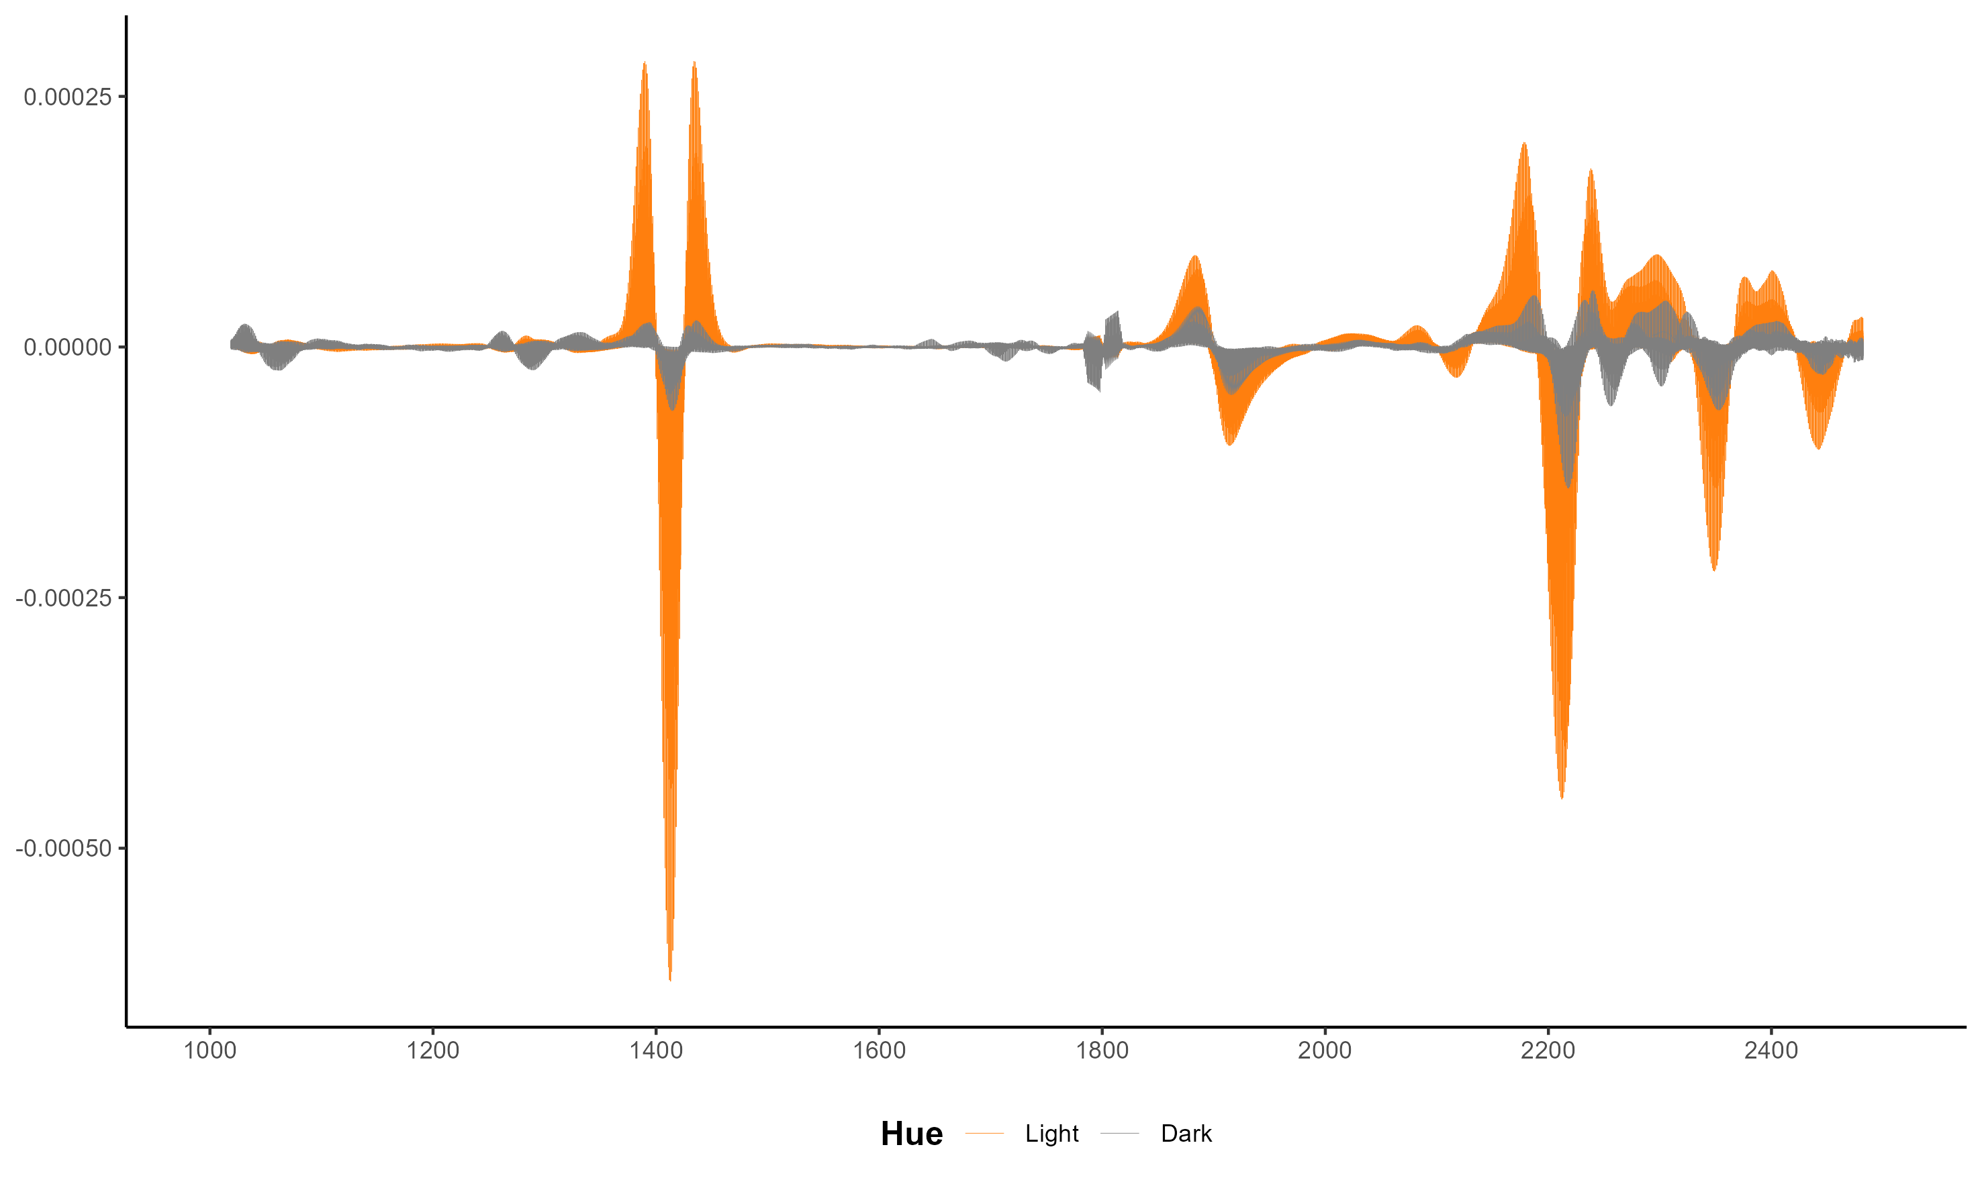

Figure 4.3: SG transformed spectra contrasting the results between the spectra in the dark (black) and light (orange) groups.

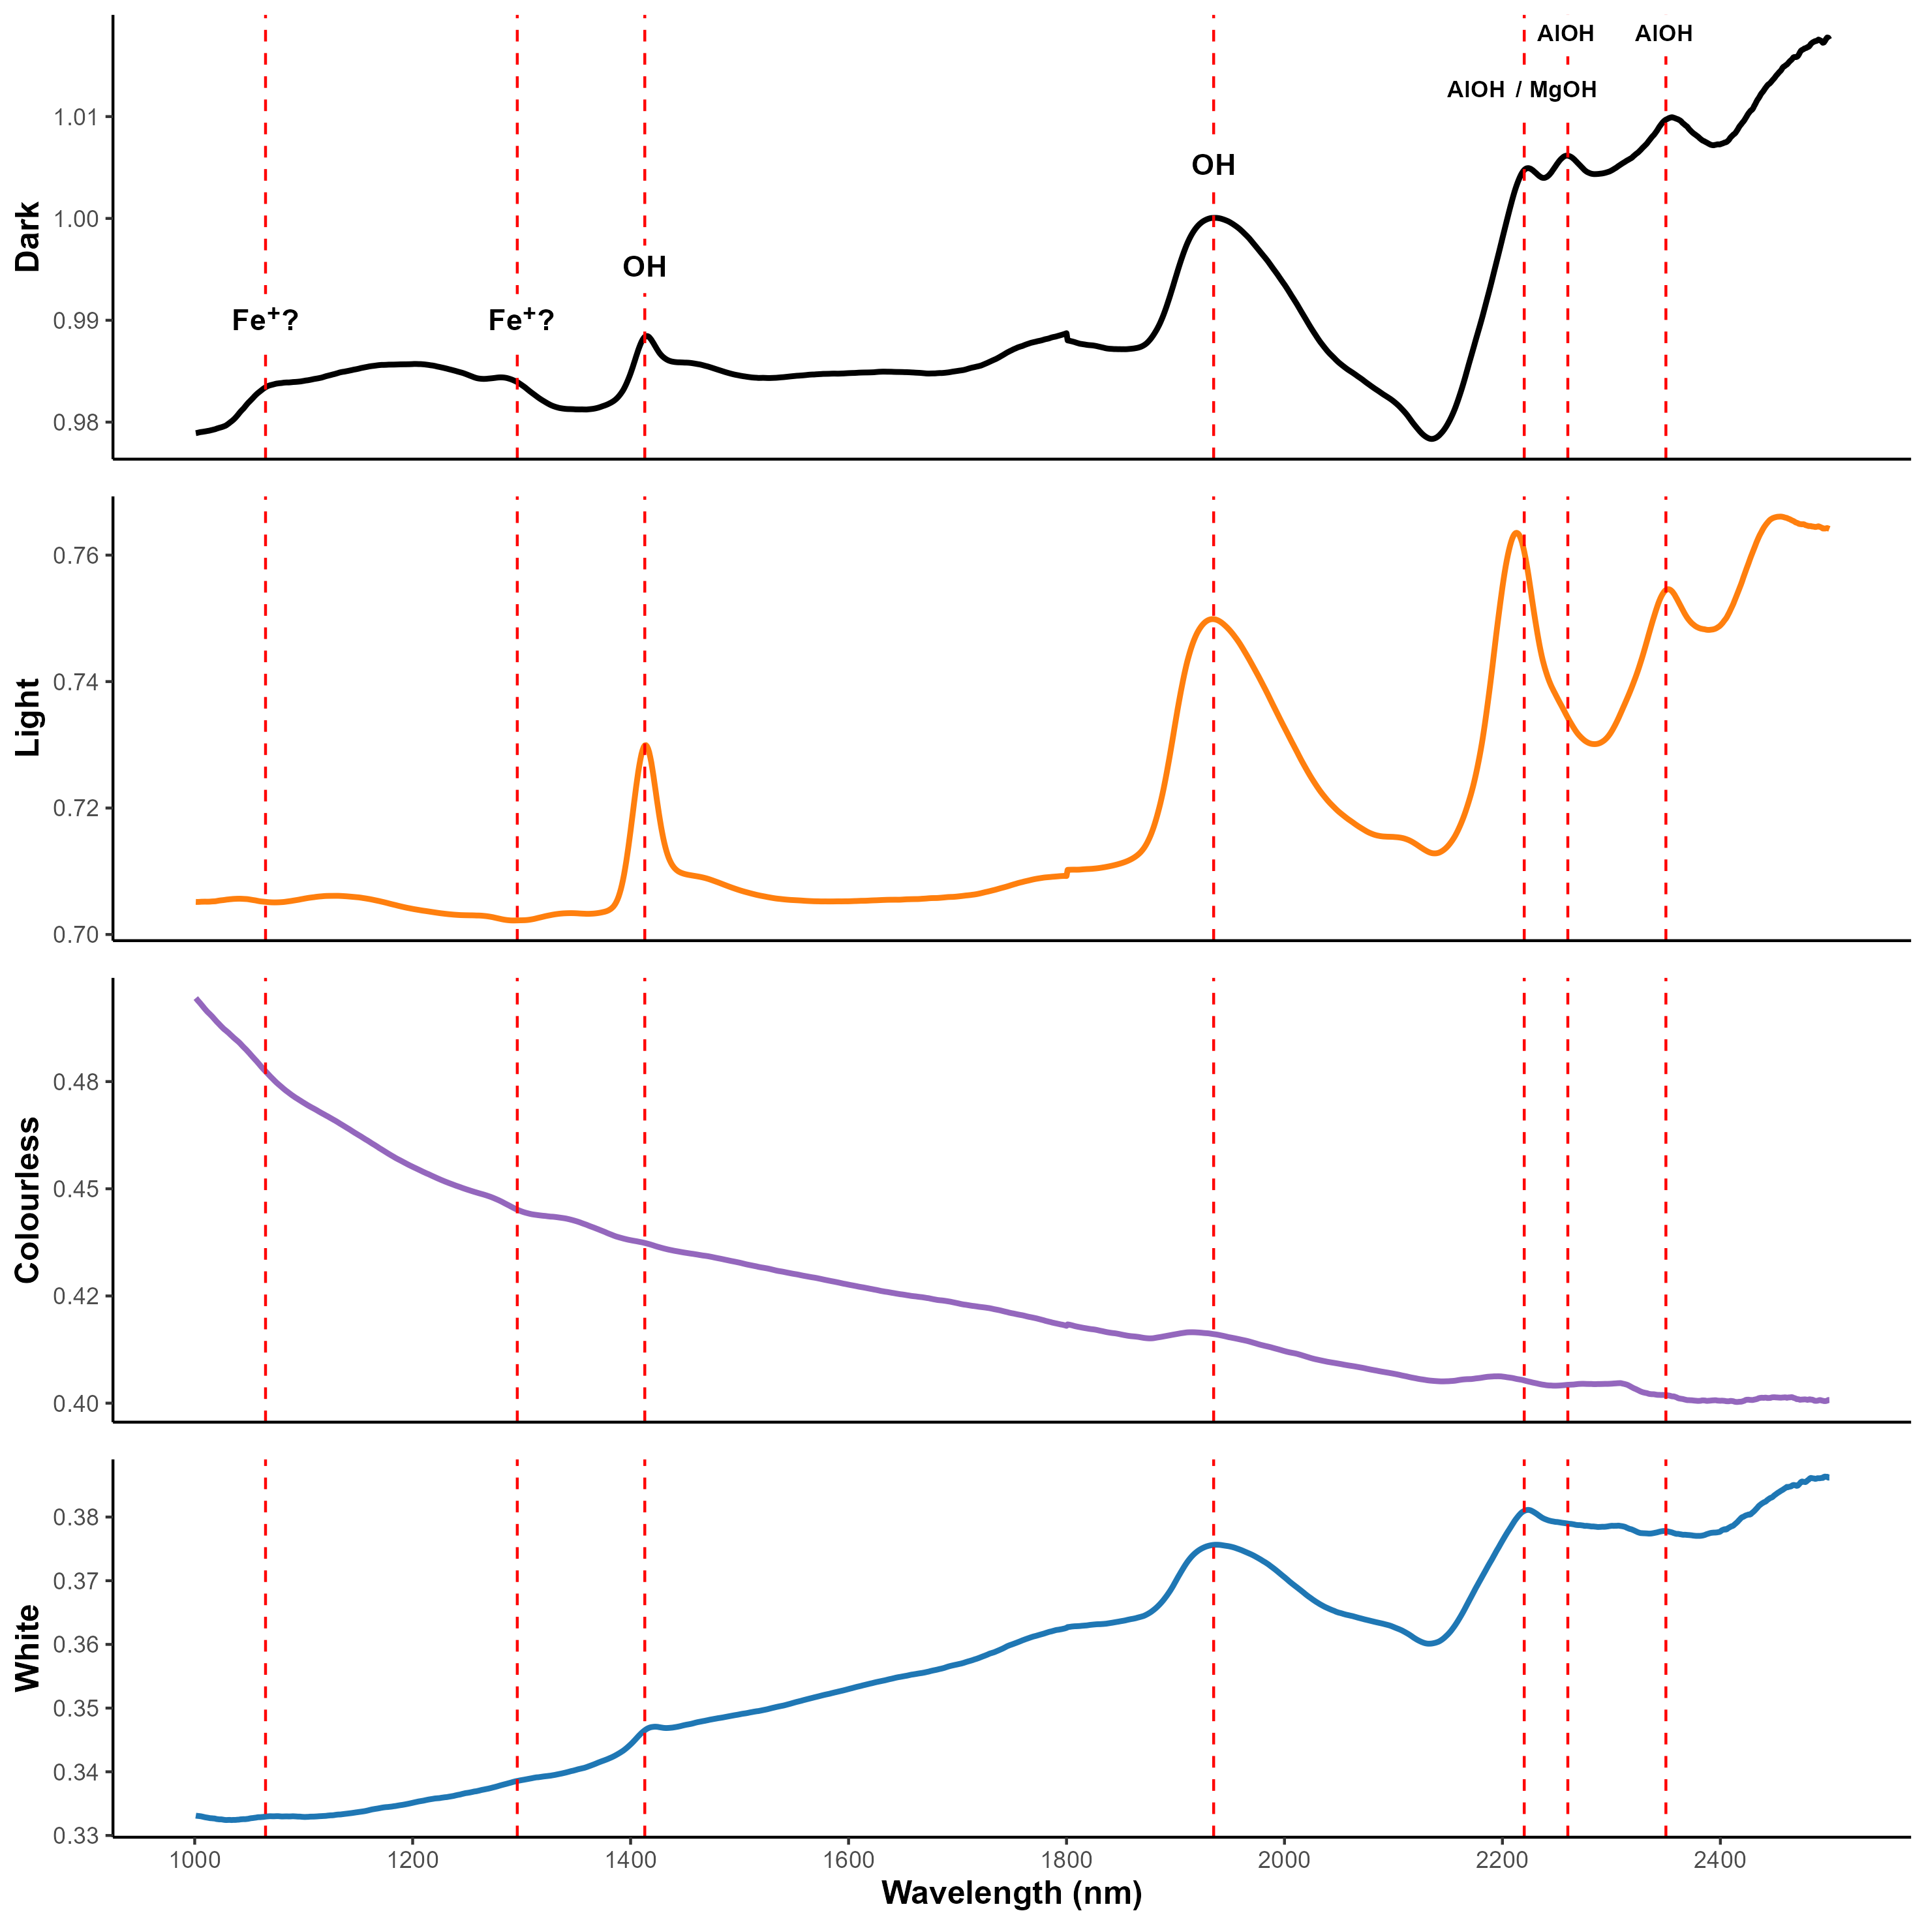

Figure 4.4: The main features in the NIR spectra can be related to overtones and vibration combinations of OH groups. The 1 400 nm and 1 900 nm peaks are indicative of molecular water, and common in quartz-based materials. The 2 200 nm and 2 350 nm bands indicate metal-OH combinations, where a more intense 2 200 nm band has typically been related to the presence of AlOH, and a more intense 2 350 nm band MgOH. Although difficult to detect in the non-processed spectra, weaker features also appear at 1 065 nm and 1 300 nm, that may be the result of ferrous iron (Fe2+)

The loading lines for the PCA can be seen in Appendix 9.1. The first principal component (PC) shows a strong trend (98.71 %) that seems to largely correlate with the absorbance of the material (fig. 4.5). This can be seen in the trend of darker material clustering towards the positive side of PC 1, with lighter towards the negative. A slight difference in the clustering of material with a light hue can also be seen along PC 2 (1.08 %). Objects with a white or light grey hue gravitate towards the bottom left of the score plot, while material that showcases some translucence cluster towards the top left. There are objects that break this trend, however, such as sample 255 in the bottom right of fig. 4.5:A.

While the explained variance of PC 3 is low, (0.13 %), it still contains a number of the aforementioned features visible in the spectra (inverse to PC 1) (Appendix 9.1). Adding PC 3 to a score plot (fig. 4.5:B), however, there seems to be little new information gained apart from a couple of samples, mainly from the light group, that break away from the remaining samples.

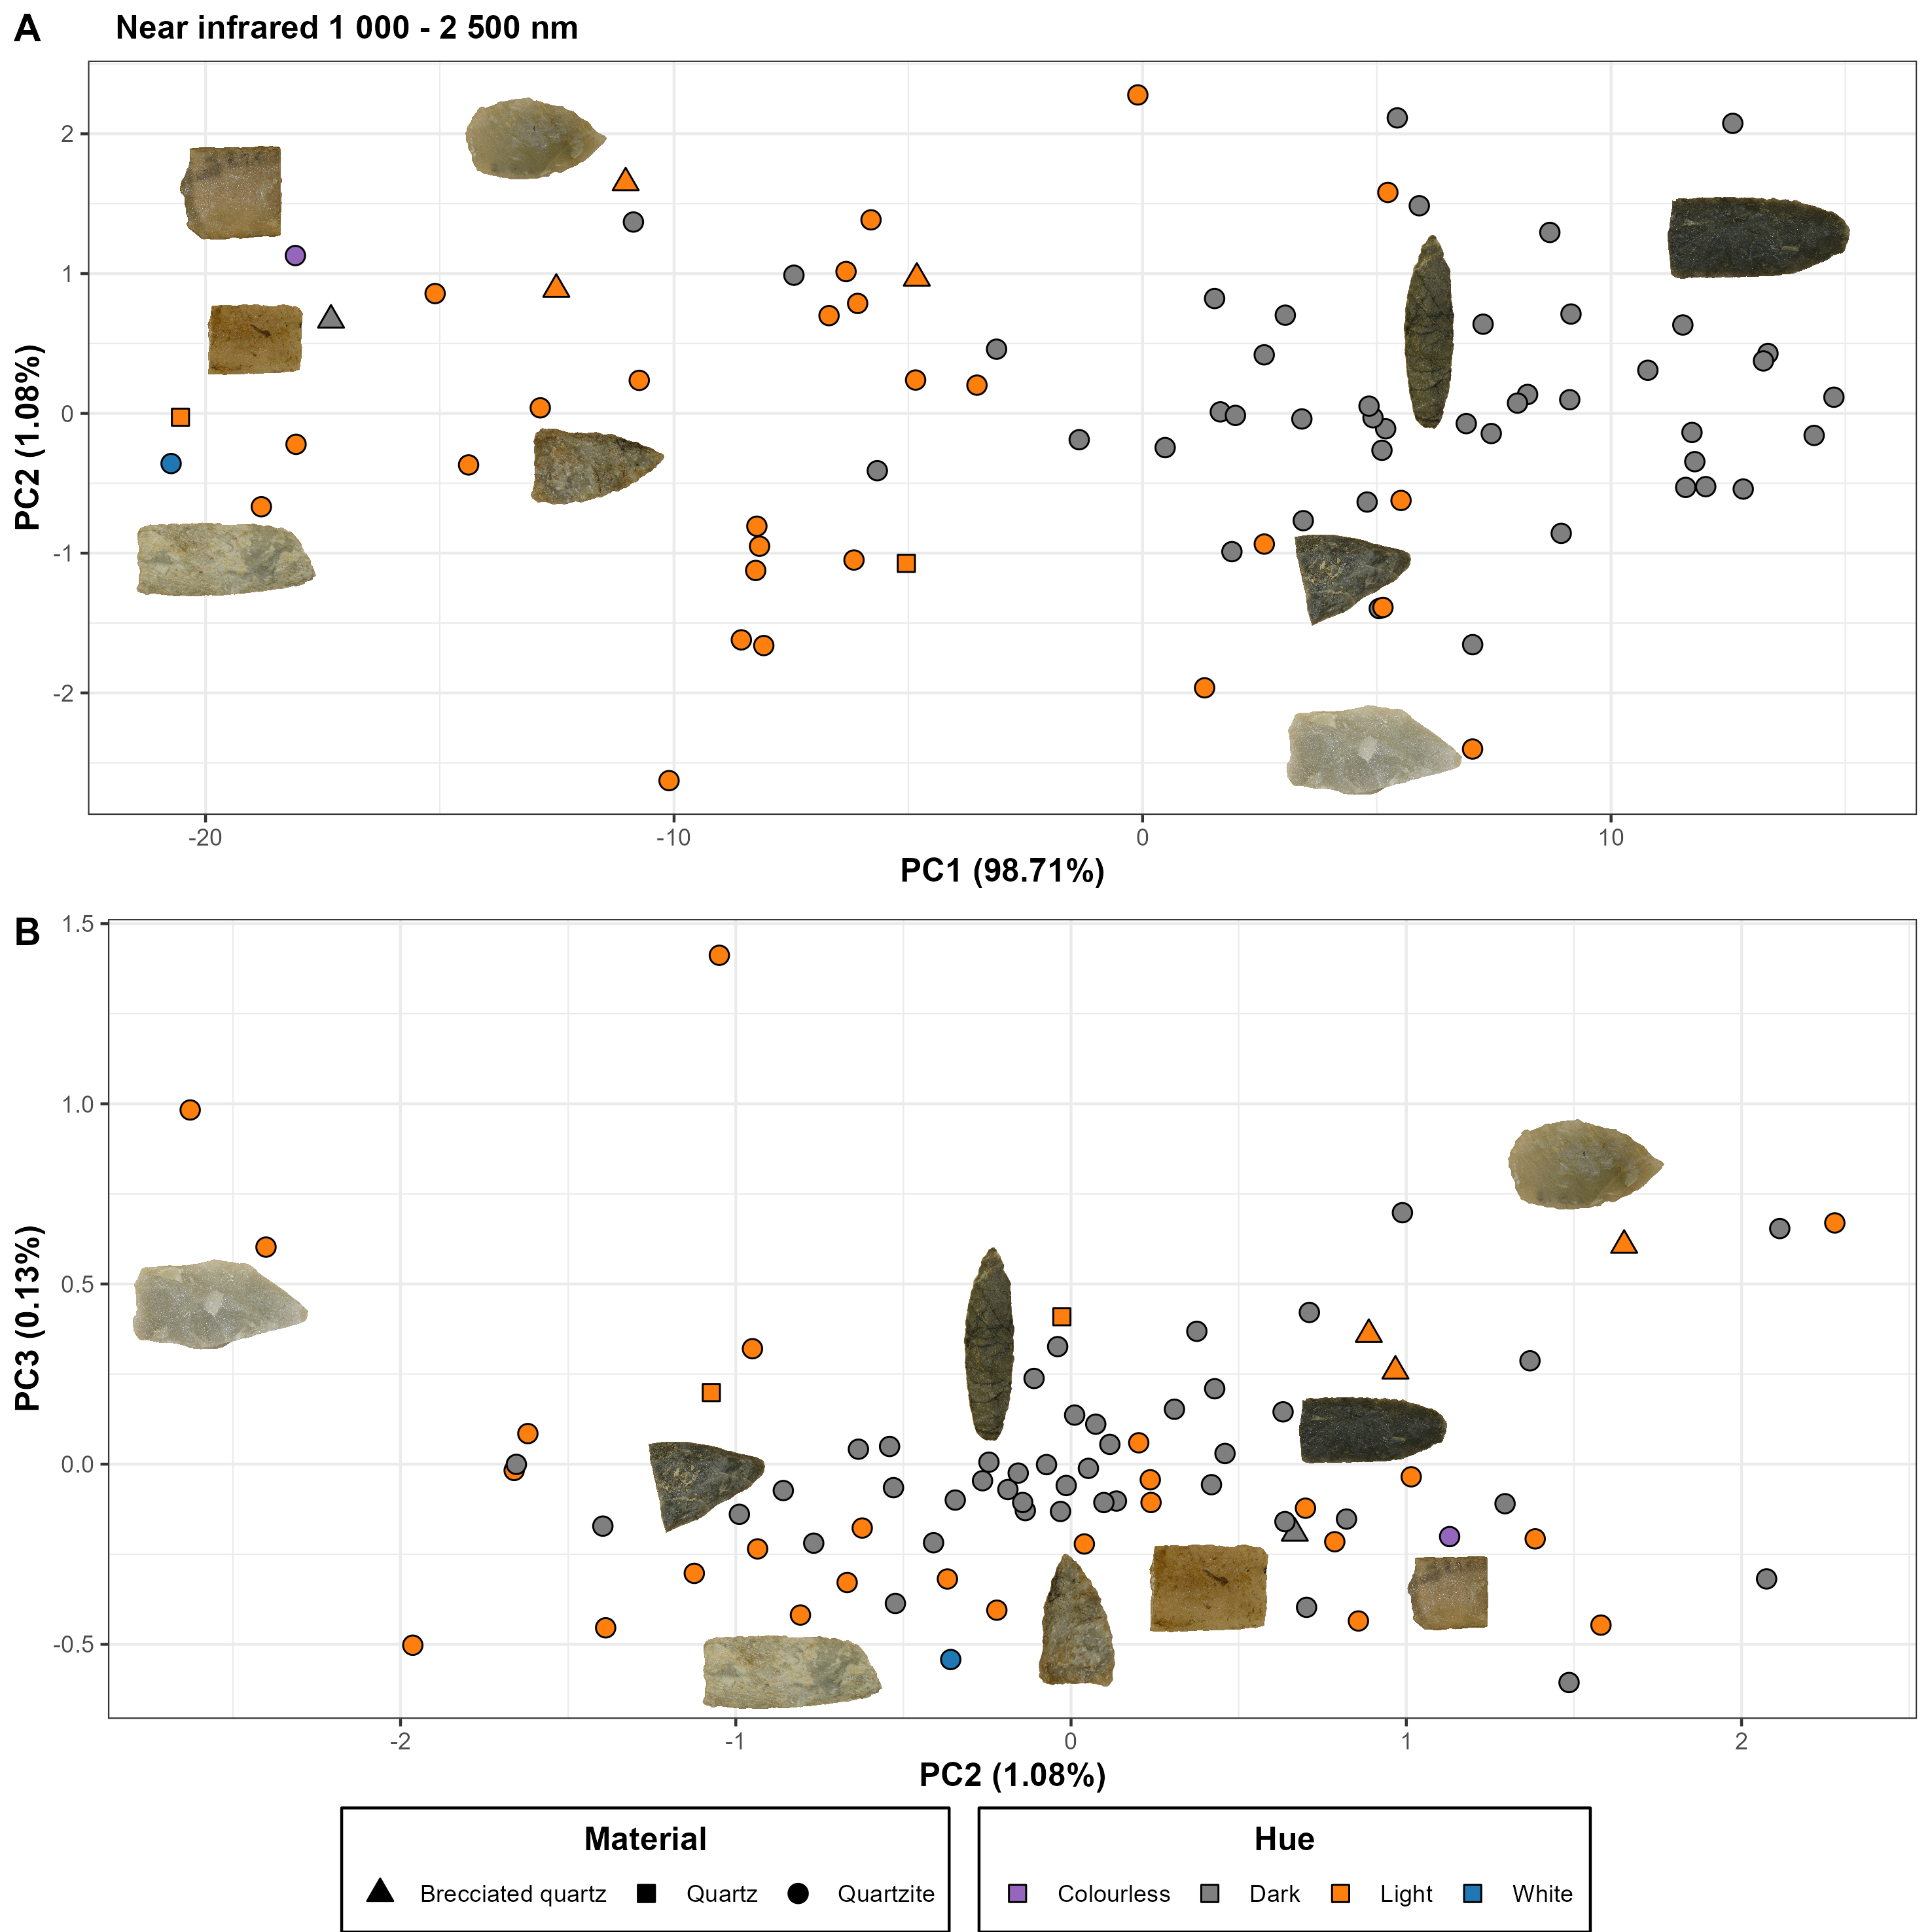

Figure 4.5: NIR PCA score plot for PC 1-3: a) dark and light material is separated out along PC 1, due to absorbance, with white and colourless material separating along PC 2, b) PC 3 adds little new information, mainly separating out a couple of light samples.

## 4.2 Raman

There are two distinguishing features present in the Raman data (fig. 4.6 & fig. 4.7), one which can be related to quartz and another that may indicate the presence of carbon (C) structures. The three initial bands at ~ 128 cm-1, ~ 200 cm-1 and ~ 460 cm-1, are some of the more intense quartz bands (Zhong et al. 2021), with the strongest peak occurring at 460 cm-1 (Gillet et al. 1990).

The second feature shows up as two peaks occurring at around 1 287 cm-1 and 1 598 cm-1, and dominate the spectra in terms of intensity for the darker samples. These peak positions fall within what is referred to as the *D* and *G* band respectively, and have been observed in spectroscopic studies of graphite (Cesare and Maineri 1999). The D band occurs as a result of disordered carbon (C) structures whilst the G band is indicative of sp2 carbon networks and caused by stretching in the carbon bonds, which is common in graphite-based materials (Cohen-Ofri et al. 2006; Vollebregt et al. 2012; Lee et al. 2021). Whereas the 2nd peak falls within the expected position of the G band, the position of the D band is commonly identified as being in the 1 330 - 1 350 cm-1 region. It has, however, been documented that the dispersive behavior of the D band can cause a frequency change as a result of the energy of the incident laser (Pimenta et al. 2007, p. 1280). This could thus explain the discrepancy between the observed peak in the dataset and the literature.

Aside from the above more intense features a couple of weaker peaks can also be seen in a number of samples. Some of these could potentially be additional quartz bands (Zhong et al. 2021), such as a weak peak at 1160 cm-1 that is somewhat obscured by the D band. Two peaks can also be found in the 700 - 800 cm-1 band range, and while the 700 cm-1 band has been found to be one of the aforementioned quartz bands, studies of clay minerals (Kloprogge 2017), and iron ore minerals (Ramanaidou et al. 2015), have also generated a response related to Si, Al and OH vibrations within the 700 - 800 cm-1 region.

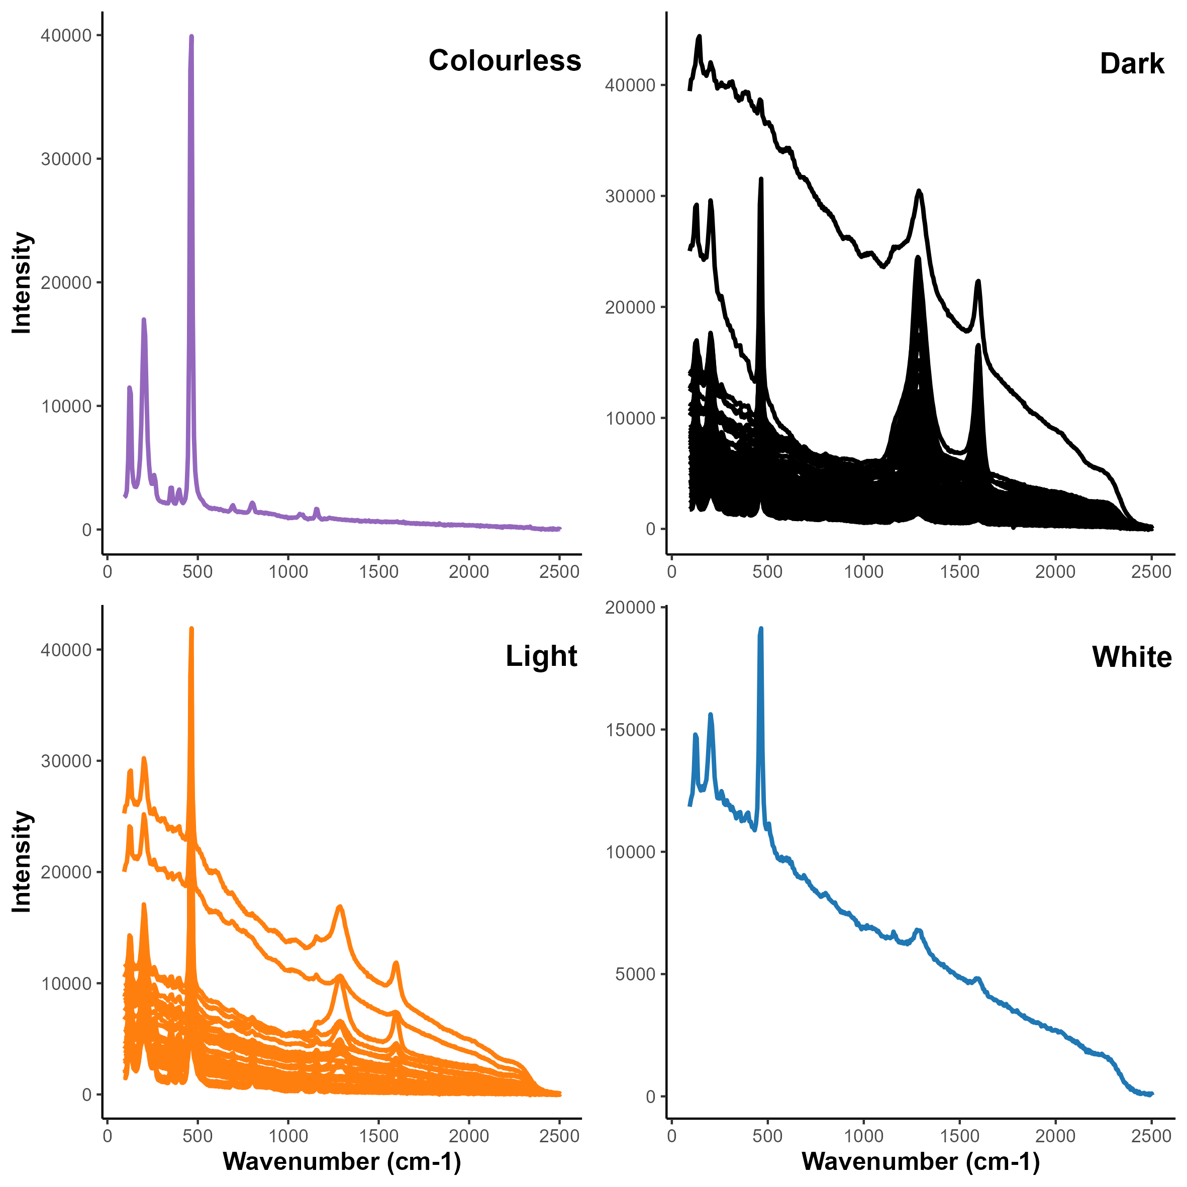

Figure 4.6: The non-processed Raman spectra visualised by colour group. Note that the dark material in general feature more intense peaks at wavenumber ~ 1 300 - 1 600 (cm-1).

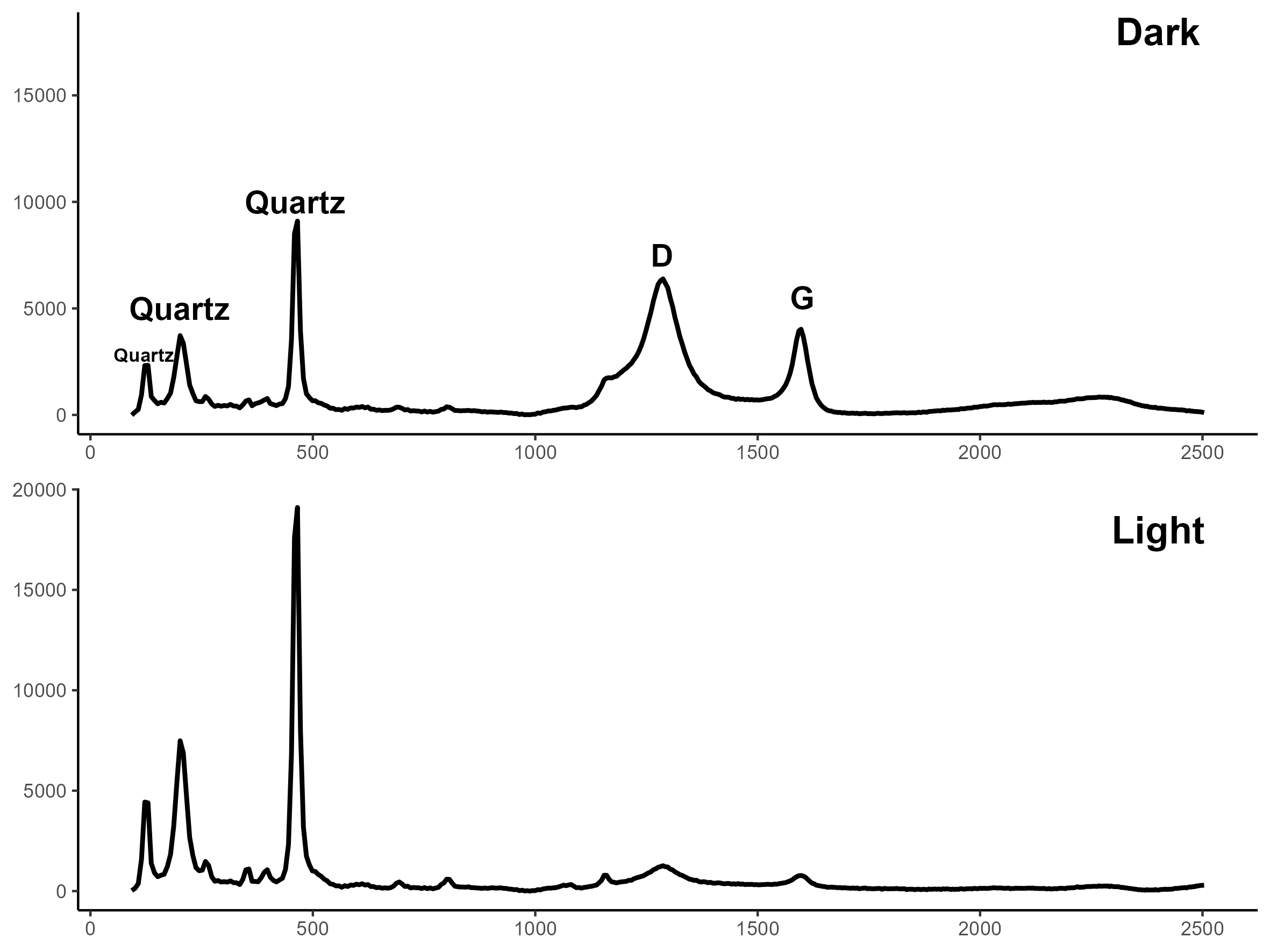

Figure 4.7: The two features that show up in the Raman spectra can be related to quartz and carbon structures in the material. The initial three peaks in the 100 - 500 cm-1 range correspond to some of the more well-known vibration modes of quartz. The 1 287 cm--1 and 1 598 cm--1 peaks fall within what is referred to as the D and G band respectively, indicating the presence of carbon structures.

The loading lines for the PCA can be seen in Appendix 9.2. The PCA model (fig. 4.8) shows a clear trend along PC 1 (75.5 %) related to the quartz and D/G peaks. Samples where the D/G peaks dominate in terms of intensity cluster towards the positive side of PC 1, with those that completely lack or have weaker D/G bands on the opposite side. Similarly, along PC 2 (21.6 %) the samples that have higher intensity D/G peaks gravitate towards the top of the score plot. Worth noting are two dark samples that completely lack D/G peaks, placing them among the light material in the left side of the plot. One of these is a brecciated quartz sample with a dark yellow tint, and thus more a sign of the difficulties with assigning a generic hue to the material. The second sample, however, stands out from the rest of the material. It is a point preform made from a grey material with a rough texture, and possible layering, with larger quartz crystals. It does not fit with the “expected” image of a quartzite, and may be a case of mischaraterization. The addition of PC 3 (2.1 %) provides no new information, but rather separates out those samples with a higher level of noise.

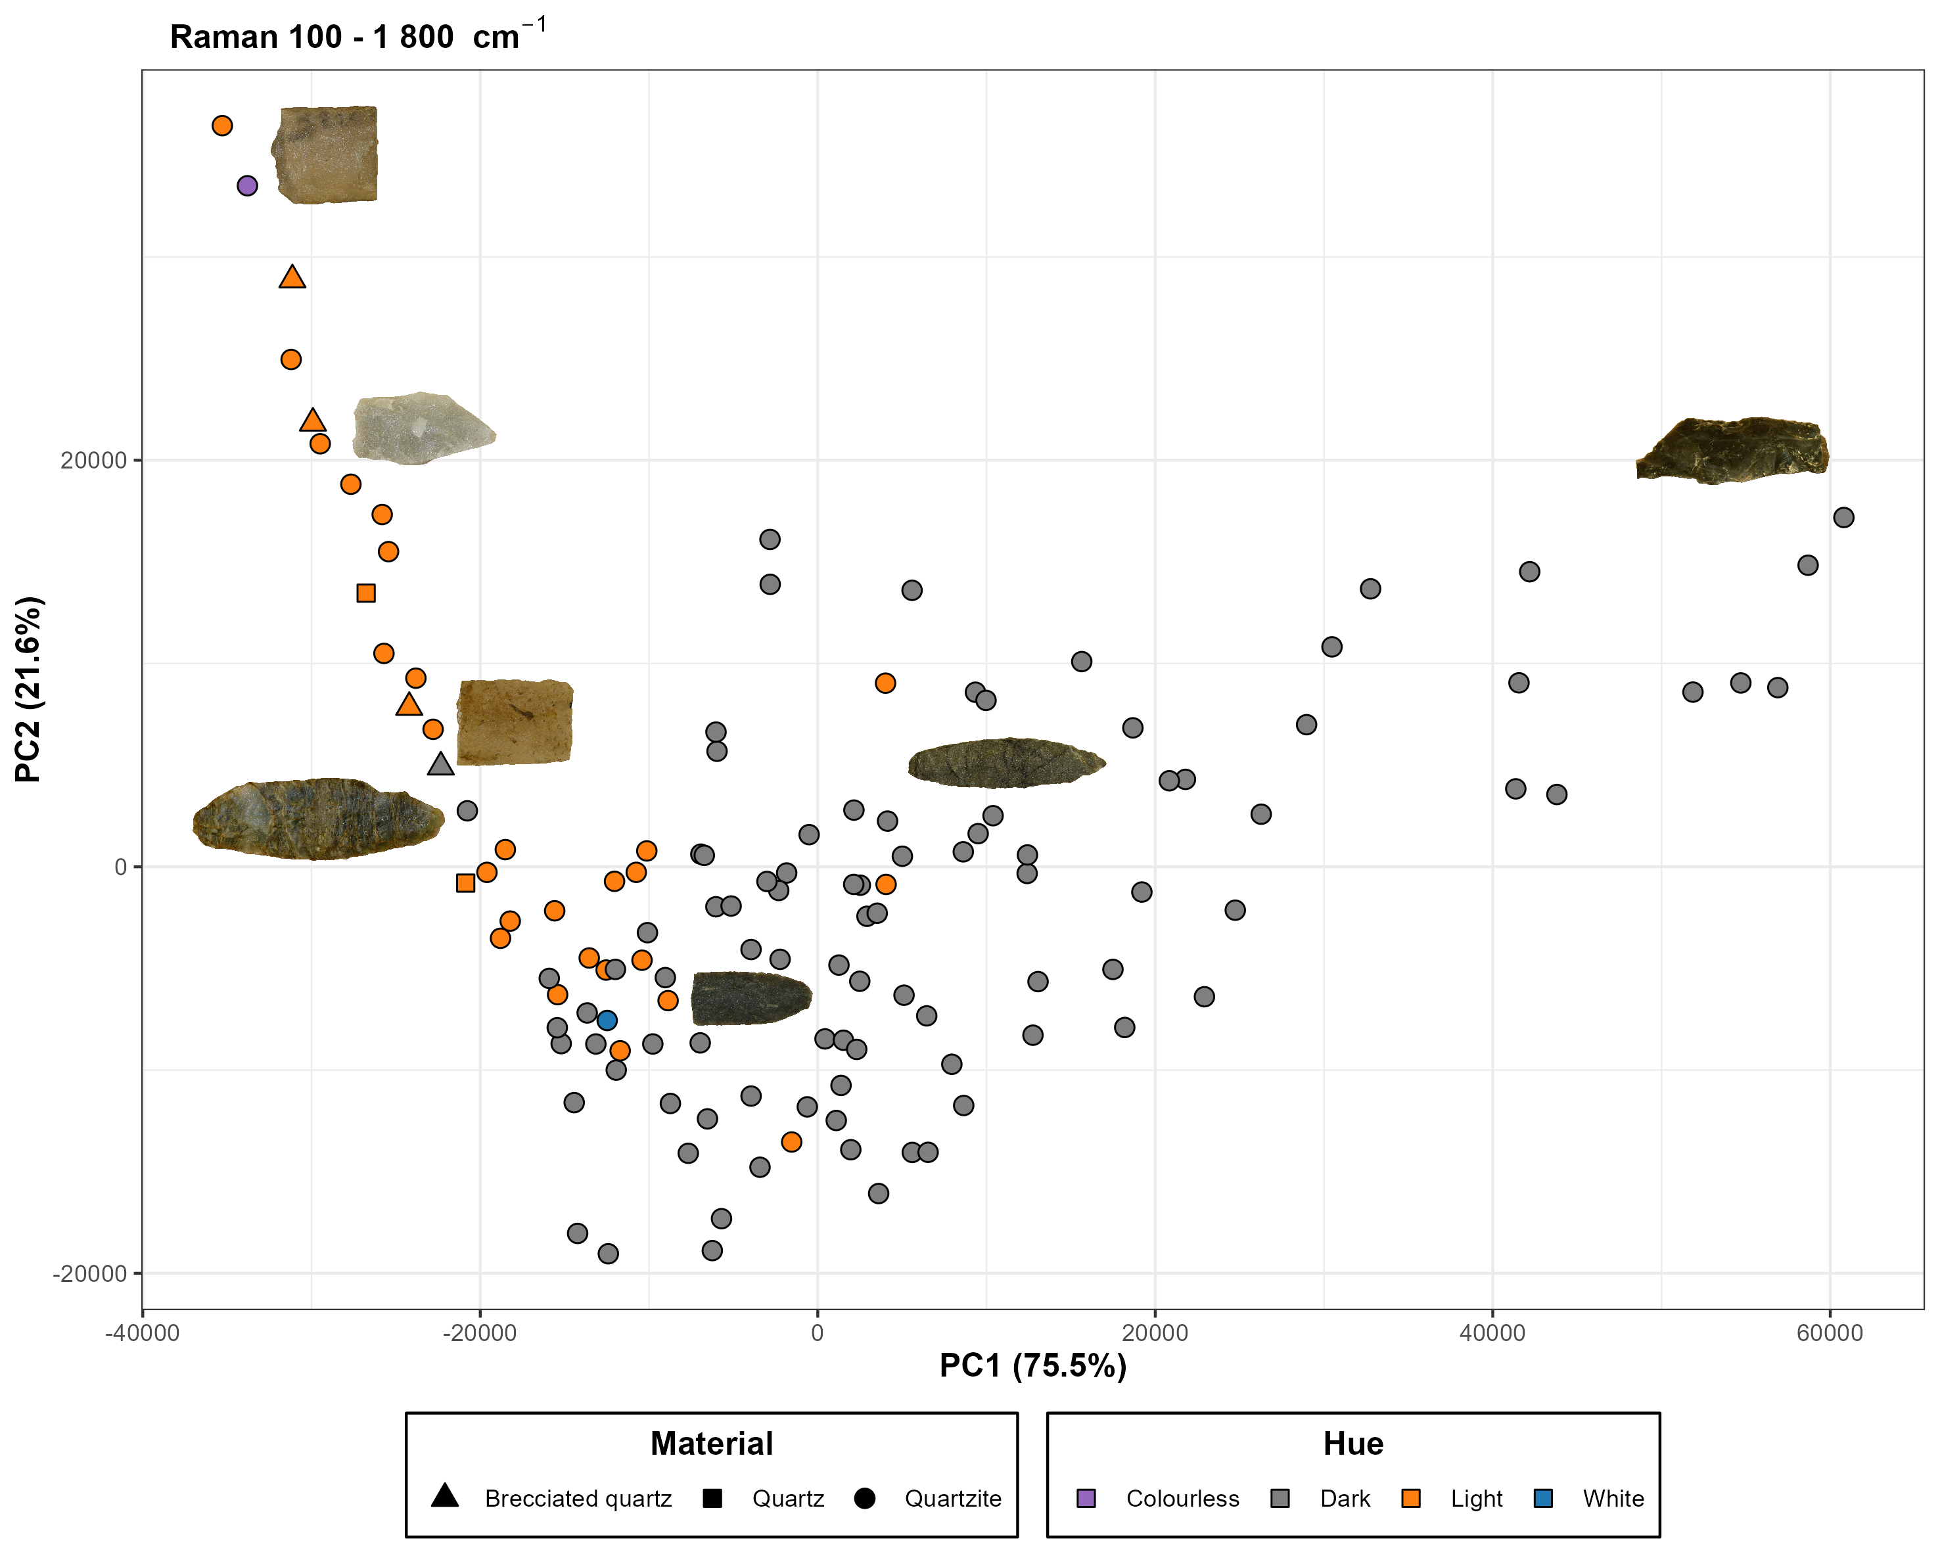

Figure 4.8: PCA score plot for Raman data. Objects that feature only quartz peaks are clustered towards the top left of the plot, whilst the darker material that feature dominant D/G peaks are distributeted towards the right of the plot. In the middle cluster the samples feature both quartz and D/G peaks, with those that have higher intensity D/G peaks in the bottom of the cluster.

## 4.3 XRF

The XRF spectrometer is not capable of detecting all of the common elements, and the software therefore calculates a balance (BAL) that represents the remaining unquantifiable elements in a sample. The elements represented in this group are all those with an atomic number lower than 12Mg (Scientific 2018). The analysis shows that 14Si makes up the main main bulk of the material, with 13Al recorded up to ~ 5% for some samples (fig. 4.9). Interestingly, the majority of the readings resulted in a 14Si content of less than 50%, as well as a BAL between 40 – 70%, meaning that a significant portion of the material remains unknown. While this could be due to the limitations of the instrumentation, it is perhaps more likely a result of the sampling. As quartzite is a metamorph rock where the distribution of quartz is not necessarily uniform in the material, the sample point can have a considerable influence on the measurement. Out of a total of 125 samples 28 measured a 14Si content higher than 90%. 12Mg, 23V, 25Mn, 39Y and 30Zn recorded a high number of values below the LOD (“missing values”), although in the case of 12Mg and 25Mn the recorded values reached up to 0.3% and 3% respectively.

The PCA was run twice, once with the > 90% 14Si samples included and a second time without them. The loadings can be seen in Appendix 9.3. The initial PCA (model A), with the full dataset included, resulted in 3 PCs with an eigenvalue above 1, and a cumulative explained variance of 66.15%. K-means cluster analysis was performed on the PCA data in order identify potential groups with similar elemental composition. Using the elbow graph method 3 clusters were deemed suitable for the analysis.

As can be seen in the score plot (fig. 4.10:A), the three K-means clusters remain separated. As expected, cluster 1 is made up of those samples that feature a high 14Si content (fig. 4.11). There is no real pattern to this cluster aside from higher 14Si values with lower 26Fe and 40Zr values. Loadings for elements that you would expect to follow changes in 14Si content also end up near cluster 1 (e.g. Al, Ca). Interestingly one of the “quartz” labelled samples ends up in cluster 3 rather than 1, and upon examining the sample visually it does not showcase any typical quartz characteristics.

Cluster 2 is marked by a higher 22Ti, 26Fe and 40Zr content on average. It mainly features samples with a dark hue, with the few samples from the light group being grey in color and arguably somewhere in between what might be considered a “dark” or “light” hue. 13Al and 19K is similarly higher in cluster 2 than compared to cluster 3, which is marked by its, on average, lower elemental content than the other two clusters. That said, cluster 3 does features a more limited range of values between the samples. The material in cluster 3 also includes all of the *brecciated quartz* samples as well as other light - colourless objects.

In the second PCA model (model B), with the high 14Si samples excluded, four PCs feature an eigenvalue above 1 with a cumulative explained variance of 71.53%. Again, 3 clusters were deemed suitable for the K-means analysis. Cluster 3 stands out by having a smaller range of values in most elements, as well as overall lower values (fig. 4.10:B), than compared to the other clusters. The *brecciated quartz* samples all remain in cluster 3, along with mainly light-to-colourless samples. Cluster 2, on the other hand, feature the main bulk of darker samples with higher 22Ti, 26Fe and 40Zr values. Cluster 1 likewise feature a large portion of the darker materials, with comparable 22Ti, 26Fe and 40Zr values. It also has higher values of 12Mg, 13Al, 16S, 19K, and 20Ca.

38Sr was detected at trace amounts. It is a lithophile element that can substitute for 20Ca in sulphates, feldspars, mica and clays (Banner 1995; Ahijado et al. 2005), which might be one explanation for its presence in cluster 1 in model B. Interestingly, nearly all samples with 38Sr are located in cluster 2 in model A.

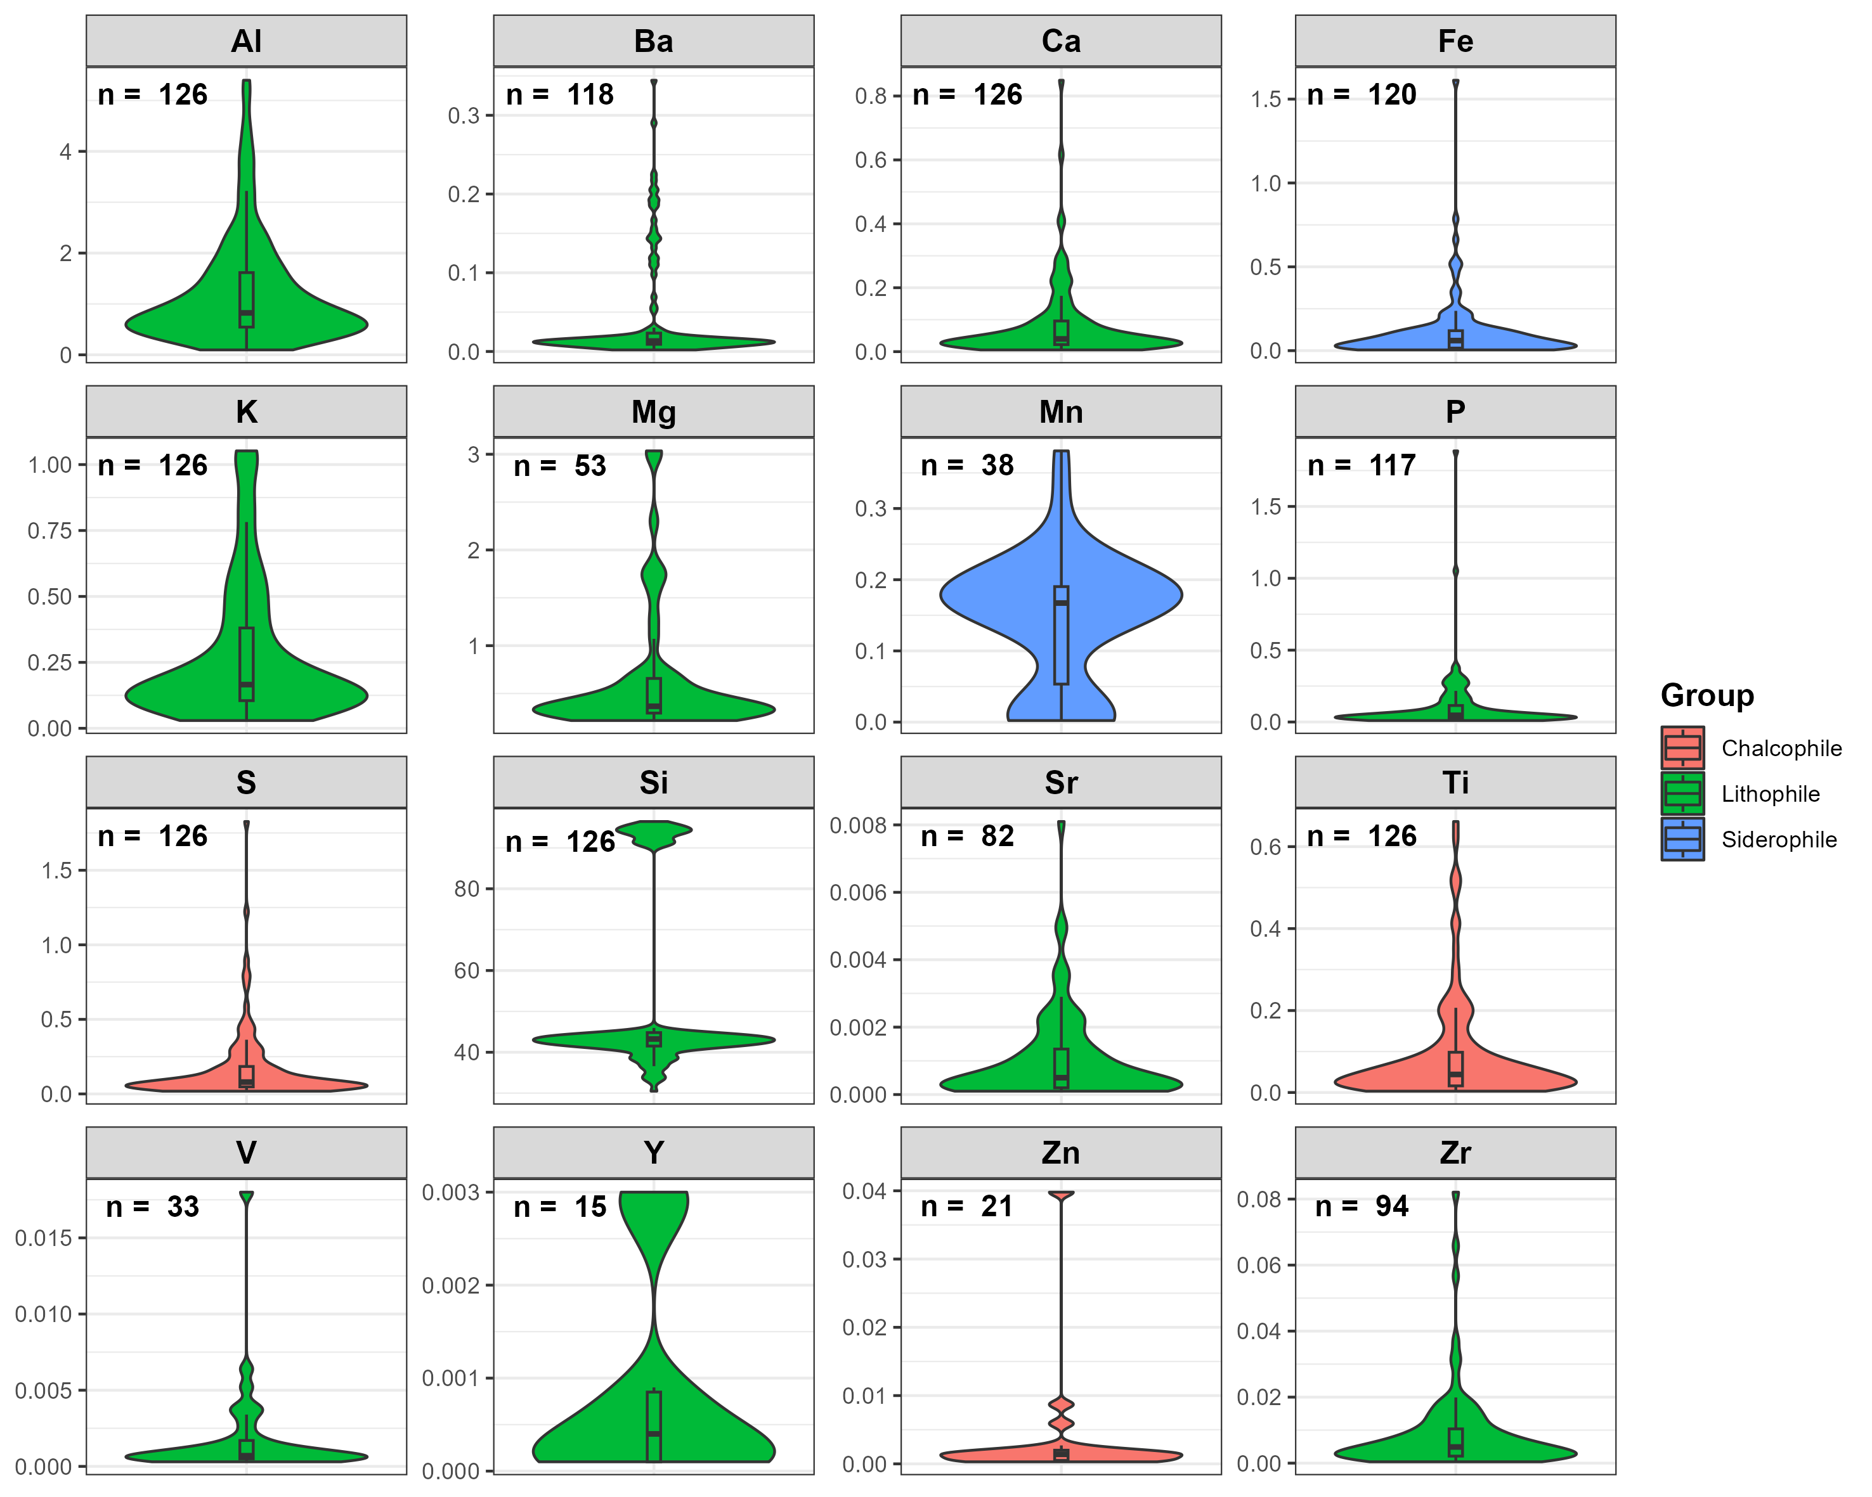

Figure 4.9: Violin plot of the XRF values per element. Median and interquartile range represented with a boxplot, surrounded by a kernel density estimation. Values above LOD is noted by *n*. The bimodal distribution of Si is visible in the plot, as well as the low number of values above LOD for V, Y and Zn.

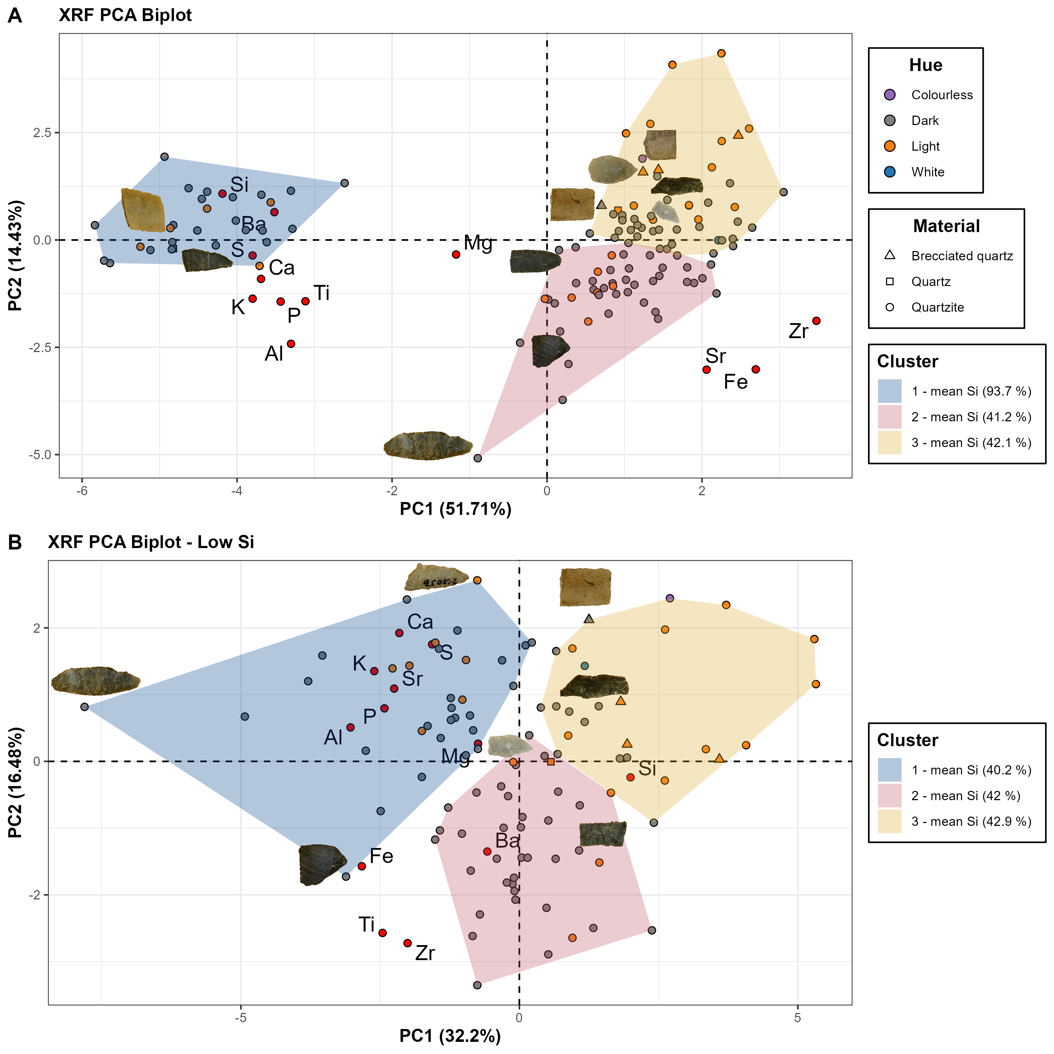

Figure 4.10: XRF PCA score plots: a) Score plot featuring the full dataset, cluster 1 includes all samples with Si > 90%, while the remaining samples seem to cluster somewhat based on Fe and Zr content. This results in most of the darker materials clustering towards the bottom of the plot. b) Score plot with > 90% Si samples excluded. Similar to plot A there is a separation based Fe and Zr values, with darker material towards the bottom of the plot. Light-to-colourless samples also remain largely together in cluster 3. Cluster 1 stands out by featuring slightly lower Si, Fe, Ti, and Zr values, but higher values in Al, Ca, K, and Mg.

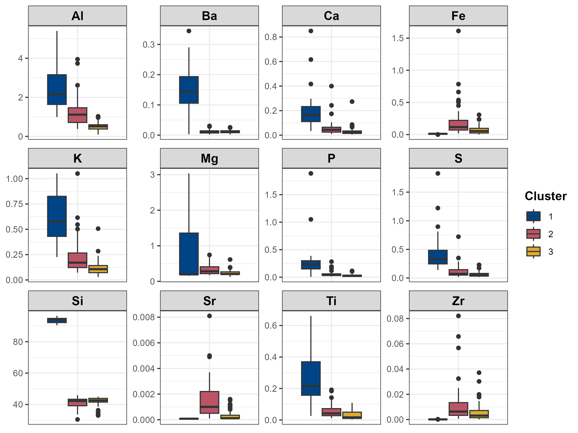

Figure 4.11: Boxplot of XRF values (%) for model A, grouped by K-means cluster. Note that cluster 1 feature all those samples with a Si value above 90%, with cluster 2 featuring higher Fe/Ti/Zr values.

The K-means cluster analysis of model B is visualised in the NIRS model, which further emphasizes the variation within the general color groups (fig. 4.12). Cluster 2, with higher 26Fe and 40Zr values, mainly coincides with the darker material to the right side of the plot. This was expected as the trend along PC 1 in the NIR PCA mainly separates the material according to absorbance. Cluster 3 in turn coincides with the lighter material in the opposite side of the model. Cluster 1, however, is fairly evenly distributed within the model along PC 1 and PC 2.

The variation that occurs within the general colour groups can be further exemplified by looking closer at three samples selected from the dark group, that each belong to a different K-means cluster. They all share a similar hue with D/G peaks detected in the Raman analysis (fig. 4.13). All three samples have similar absorbance values, but sample 391 exhibits some differences in the spectra compared to the other two samples. Out of the three objects sample 391 seems to stand out more clearly from the others, with the XRF analysis being what mainly seems to separate the other two.

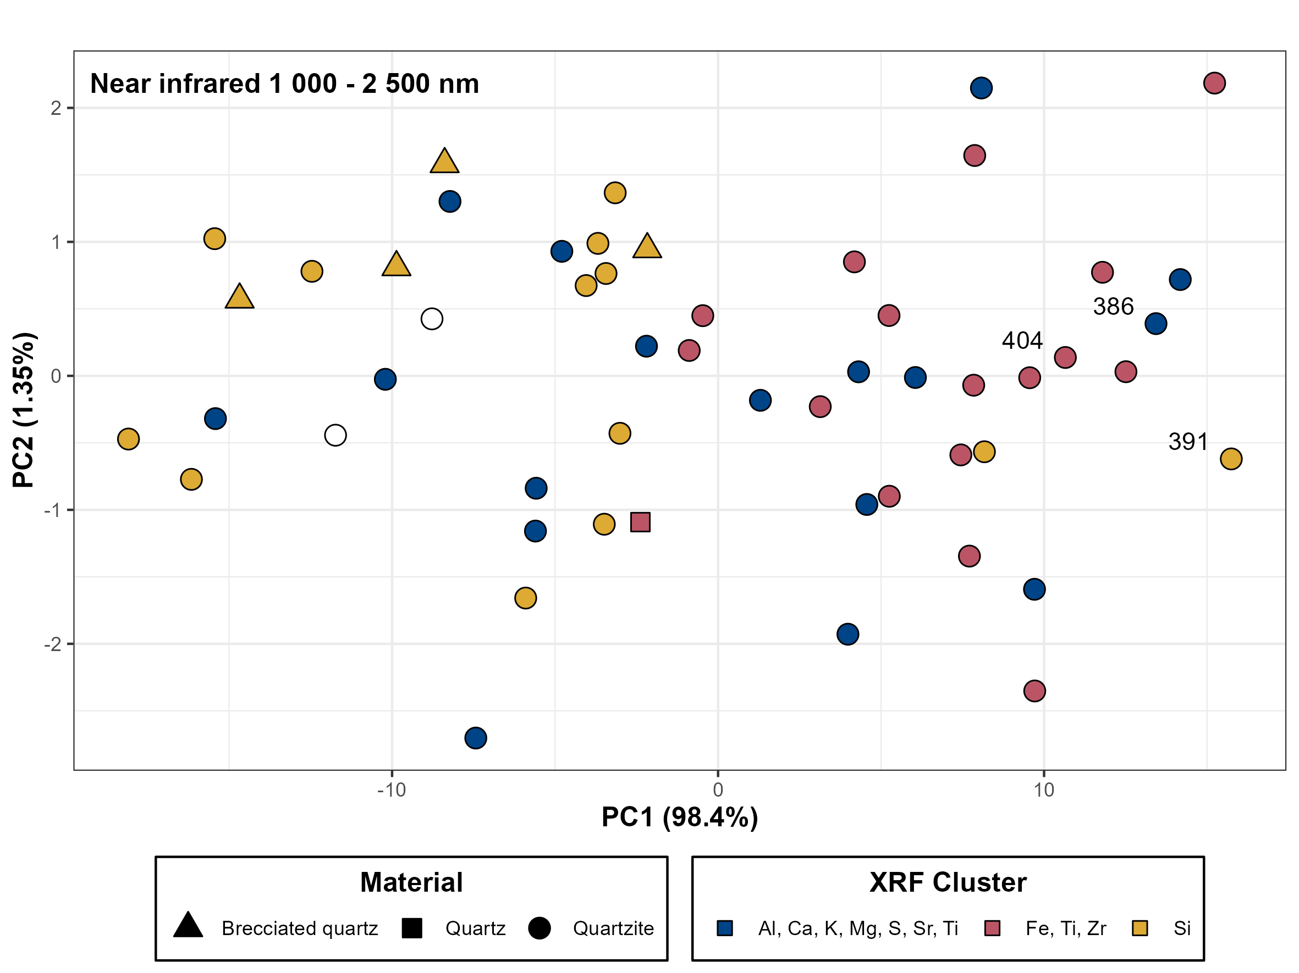

Figure 4.12: NIR PCA score plot for PC 1-2, with the K-means cluster from XRF PCA model B visualised in the colour of the points. White points are samples that were excluded in the XRF PCA. The trend separating dark-light samples in the NIR PCA mostly keeps cluster 2-3 separated, showing some overlap in the results, but cluster 1 is fairly evenly distributed in the score plot. This means that whatever differences can be discerned in the compositional data does not seem to be detectable using the ASD.

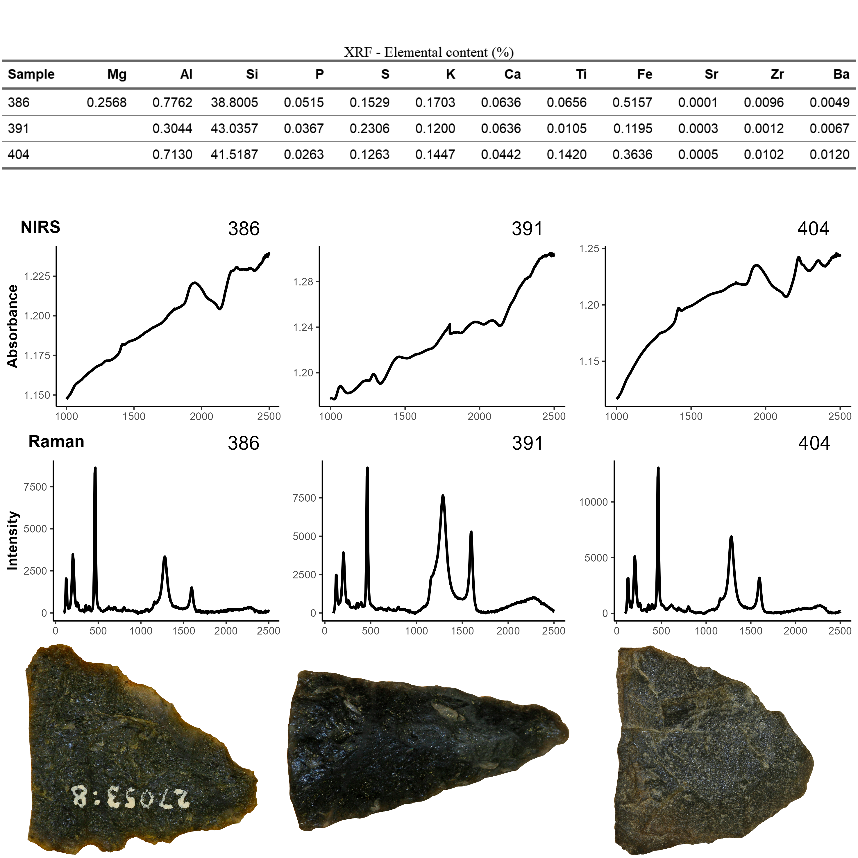

Figure 4.13: Comparison of three dark samples from separate K-cluster groups (model B). Sample 391 from cluster 3 stands out the most with visible differences in both the NIR and Raman spectra, when compared to the other samples. The main difference between samples 386 and 404 seems to mainly be in the XRF data.

# 5 Discussion

The exploratory evaluation of spectroscopic data generated on quartz/quartzite points and preforms demonstrates that valuable information on the composition and structural properties of the material can be gained via non-destructive analysis. As the identified features are related to the diagenetic/paragenetic environment they should be useful in future survey efforts aimed at locating possible geological sources. This does not, however, address the issues related to the resource procurement strategies employed by people within the region during the 4 000 - 2 000 BP period, as the material may have been sourced from other glacial and postglacial landforms, into which the material may have been incorporated. One way of addressing this issue would be to construct a predictive model based solely on the spectroscopic fingerprints of the large unknown dataset, which could form the basis of spatial analysis and hypothesis testing.

One benefit of non-destructive screening is the relative ease with which large datasets can be generated. Although the resolution may be affected to some degree, it lends itself quite well to the exploratory approach and hypothesis generation. A non-destructive approach is quite effective in regions such as Northern Sweden, where little development has been made in regards to the chemical characterization of quartzite and there are many unknowns. There is now a better understanding of the chemical and structural variation that exists under the umbrella of what archaeologists refer to as *quartzite*, at least within the Västerbotten area. Visually the material varies greatly, both in terms of texture as well as color. The initial classification of the material is primarily based on the archaeological documentation from the surveys and excavations, but as was highlighted in the results, there seems to be some instances of possible mischaracterization due to this. It is an important reminder to be mindful when aggregating data where the analyst is not the primary producer.

As quartzite is a metamorphic rock there are two factors to consider that will affect its chemical and structural properties; the make-up of the original depositional context, and the grade of metamorphism (in the case of sedimentary orthoquartzite it is mainly the former). The “graphite peaks” are a good indicator of such information, which could point towards the material forming in carbon-rich formations, thus helping in delimiting possible geological source areas. Usage of the term, “graphitic quartzite”, can actually be found in an early 20th century description of an excursion to Storfjället, Tärna parish, by the Geological Society (Geologiska Föreningen i Stockholm 1925), but otherwise does not seem to be a frequently used term in modern day Sweden. Metamorphic rocks containing graphite, including schist and quartzite, are a common enough occurrence in other regions (e.g. Gawęda and Cebulak 1999; Ukar and Cloos 2016). Considering the presence of Alum shale and similar carbon-rich tectonic strata within the Scandian mountain chain (Stephens and Bergman Weihed 2020, pp. 482–ff), it would not be strange to encounter carbon structures in quartzite or quartzite-like material. The metal-OH features in the NIRS data is another likely piece of evidence which could be helpful in separating quartzite based on metamorphic grade.

Due to the high representation of quartz and quartzite in the lithic assemblages dating to the Mesolithic - Bronze Age in Northern Sweden (Baudou 1978), it is vital that methods for characterization of these materials are developed. As they represent a primary lithic resource they hold a critical position in the study of resource procurement, trade and exchange and human mobility within the region (as well as many other regions (e.g. Prieto et al. 2019)). Previous studies have primarily relied on visual characterization following a system that was setup in order to manage the large quantities of data generated following the large scale development for hydroelectric power during the 1940s - 1980s (Biörnstad 2006; Käck 2009, pp. 53–55). This was necessary in order to manage the overabundance of data and make sense of it at the time, and provided a lot of new insights (e.g. Forsberg 1985; Holm 1991; Lundberg 1997), but there has been little development in regards to questions of provenance of these materials since. This study addresses those needs and demonstrates the potential which exists for increasing the understanding of human resource management of locally available lithic material.

# 6 Conclusion

The results demonstrate clearly that non-destructive application of all three instrumentations (NIRS, Raman, XRF) are capable of petrographically characterizing some aspect of the quartz and quartzite, however, taken on their own they lack the resolution needed to provide a detailed enough fingerprint for classification. Nevertheless, they do provide a more in-depth understanding of the composition and structure of the material, as well as showcase the complexity in the petrographic character of quartz and quartzite materials. The study provides an example of a non-destructive and exploratory approach to the characterization of petrographic material where there also is an absence of reference material. Not only is there a need for methodological development in the study of quartzite in archaeology, but there is also a need for methodologies that can be applied in regions with a complex geological setting and ambiguous distribution of potential geological sources. Taking full advantage of the short integration time of these instruments it is possible to build large comprehensive datasets that then can be explored and mined for information, and ultimately used to produce predictive models which can be applied to spatiotemporal questions of raw material management.

# 7 Acknowledgements

I would like to thank Professor Paul Geladi, as well as my supervisor Dr. Johan Linderholm, for valuable insights and comments on the methodological aspects of this paper.

# 8 References

Adams JB (1975) [4 - INTERPRETATION OF VISIBLE AND NEAR-INFRARED DIFFUSE REFLECTANCE SPECTRA OF PYROXENES AND OTHER ROCK-FORMING MINERALS](https://doi.org/10.1016/B978-0-12-399950-4.50009-4). In: Karr C (ed) Infrared and Raman Spectroscopy of Lunar and Terrestrial Minerals. Academic Press, pp 91–116

Ahijado A, Casillas R, Nagy G, Fernández C (2005) Sr-rich minerals in a carbonatite skarn, Fuerteventura, Canary Islands (Spain). MINER PETROL 84:107–127. <https://doi.org/10.1007/s00710-005-0074-8>

Åhman E (1967) Riksantikvarieämbetets norrlandsundersökningar 4. Petrografisk översikt av Umeälvsmaterialet. Fornvännen 8–11

Aitchison J (1999) Logratios and Natural Laws in Compositional Data Analysis. Mathematical Geology 31:563–580. <https://doi.org/10.1023/A:1007568008032>

Banner JayL (1995) Application of the trace element and isotope geochemistry of strontium to studies of carbonate diagenesis. SEDIMENTOLOGY 42:805–824. <https://doi.org/10.1111/j.1365-3091.1995.tb00410.x>

Bargel TH (2003) Quaternary geological Mapping of Fennoscandia and Nordland: Deglaciation, Deposits, Stratigraphy, and Applications. Norges teknisk-naturvitenskapelige universitet

Baudou E (1978) Kronologi och kulturutveckling i mellersta Norrland under stenåldern och bronsåldern. In: Huggert A (ed) Studier i Norrländsk forntid. Västerbottens museum, Umeå

Baudou E (1992) Norrlands forntid : Ett historiskt perspektiv. Wiken, Höganäs

Binford LR (1979) [Organization and Formation Processes: Looking at Curated Technologies](https://www.jstor.org/stable/3629902). Journal of Anthropological Research 35:255–273

Biörnstad M (1968) Forskningsprojektet Norrlands tidiga bebyggelse. Fornvännen 178–185

Biörnstad M (2006) Kulturminnesvård och vattenkraft 1942-1980: En studie med utgångspunkt från Riksantikvarieämbetets sjöregleringsundersökningar. Kungl. Vitterhets historie och antikvitets akademien, Stockholm

Blomme A, Degryse P, Van Peer P, Elsen J (2012) The characterization of sedimentary quartzite artefacts from Mesolithic sites, Belgium. Geologica Belgica 15:193–199

Broadbent N (1979) Coastal resources and settlement stability : A critical study of a Mesolithic site complex in northern Sweden. Institutionen för arkeologi, särskilt nordeuropeisk, Uppsala

Callahan E, Forsberg L, Knutsson K, Lindgren C (1992) Frakturbilder.: Kulturhistoriska kommentarer till kvarts säregna sönderfall vid bearbetning. Tor 25:27–63

Cesare B, Maineri C (1999) Fluid-present anatexis of metapelites at El Joyazo (SE Spain): Constraints from Raman spectroscopy of graphite. Contributions to mineralogy and petrology 135:41–52. <https://doi.org/10.1007/s004100050496>

Chryssikos GD, Gates WP (2017) [Chapter 4 - spectral manipulation and introduction to multivariate analysis](https://doi.org/10.1016/B978-0-08-100355-8.00004-7). In: Gates WP, Kloprogge JT, Madejová J, Bergaya F (eds) Infrared and raman spectroscopies of clay minerals. Elsevier, pp 64–106

Clark R, King T, Klejwa M, et al (1990) High spectral resolution reflectance spectroscopy of minerals. Journal of Geophysical Research 95:12653–12680

Cohen-Ofri I, Weiner L, Boaretto E, et al (2006) Modern and fossil charcoal: Aspects of structure and diagenesis. Journal of Archaeological Science 33:428–439. <https://doi.org/10.1016/j.jas.2005.08.008>

Dalpra CL, Pitblado BL (2016) Discriminating Quartzite Sources Petrographically in the Upper Gunnison Basin, Colorado: Implications for Paleoamerican Lithic-Procurement Studies. PaleoAmerica 2:22–31. <https://doi.org/10.1080/20555563.2015.1137684>

Dubessy Jean, Caumon M~C, Rull F (eds) (2012) Applications of Raman spectroscopy to earth sciences and cultural heritage. European Mineralogical Union and Mineralogical Society of Great Britain & Ireland, London

Duke EF (1994) Near infrared spectra of muscovite, Tschermak substitution, and metamorphic reaction progress; implications for remote sensing. GEOLOGY 22:621–624. <https://doi.org/10.1130/0091-7613(1994)022<0621:NISOMT>2.3.CO;2>

Forsberg L (1985) Site variability and settlement patterns: An analysis of the hunter-gatherer settlement system in the Lule River Valley, 1500 B.C.-B.C./A.D. Umeå University

Forsberg L (1989) Ett försök att urskilja sociala territorier i Norrland under bronsålder och förromersk järnålder. Regionale forhold i nordisk bronzealder: 5 Nordiske symposium for bronzealderforskning på Sandbjerg Slot 1987 169–173

Forsberg L (2012) Asymmetric twins? Some reflections on coastal and inland societies in the Bothnian area during the Epineolithic and Early Metal Age. In: N., Wrigglesworth A&M (eds) Local Societies in Bronze Age Northern Europe. Equinox, London, pp 31–55

Gawęda A, Cebulak S (1999) [The origin of graphite in the crystalline basement of the Western Tatra Mountains (Western Carpathians, S-Poland)](http://www.geologicacarpathica.com/browse-journal/volumes/50-4/article-134/). Geologica Carpathica 50:295–303

Geladi P, Linderholm J (2020) [2.03 - Principal Component Analysis☆](https://doi.org/10.1016/B978-0-12-409547-2.14892-9). In: Brown S, Tauler R, Walczak B (eds) Comprehensive Chemometrics (Second Edition). Elsevier, Oxford, pp 17–37

Geologiska Föreningen i Stockholm (1925) Mötet den 5 februari 1925. Geologiska Föreningen i Stockholm Förhandlingar 47:145–154. <https://doi.org/10.1080/11035892509443187>

Gillet P, Le Cléac’h A, Madon M (1990) High-temperature raman spectroscopy of SiO2 and GeO2 Polymorphs: Anharmonicity and thermodynamic properties at high-temperatures. Journal of Geophysical Research: Solid Earth 95:21635–21655. <https://doi.org/10.1029/JB095iB13p21635>

Grunsky EC, Caritat P de (2020) State-of-the-art analysis of geochemical data for mineral exploration. Geochemistry: Exploration, Environment, Analysis 20:217–232. <https://doi.org/10.1144/geochem2019-031>

Halén O (1994) Sedentariness during the Stone Age of Northern Sweden : In the light of the Alträsket site, c. 5000 B.C., And the Comb Ware site Lillberget, c. 3900 B.C. : Source critical problems of representativity in archaeology

Hall ET (1960) X-RAY FLUORESCENT ANALYSIS APPLIED TO ARCHAEOLOGY. Archaeometry 3:29–35. <https://doi.org/10.1111/j.1475-4754.1960.tb00514.x>

Hanson BA (2016) ChemoSpec: Exploratory Chemometrics for Spectroscopy

Holm L (1991) [The use of stone and hunting of reindeer a study of stone tool manufacture and hunting of large mammals in the central Scandes c. 6000-1 BC](http://urn.kb.se/resolve?urn=urn:nbn:se:umu:diva-66938 Fritt tillgänglig via Umeå universitetsbibliotek). Dept. of Archaeology [Institutionen för arkeologi], Umeå University, Umeå

Howard JL (2005) The Quartzite Problem Revisited. The Journal of Geology 113:707–713. <https://doi.org/10.1086/449328>

Hunt GR (1977) Spectral signatures of particular minerals in the visible and near infrared. Geophysics 42:501–513

Käck J (2009) Samlingsboplatser? : En diskussion om människors möten i norr 7000 f kr-kr f med särskild utgångspunkt i data från ställv... Institutionen för idé- och samhällsstudier, Umeå universitet, Umeå

Kloprogge JT (2017) [Chapter 6 - raman spectroscopy of clay minerals](https://doi.org/10.1016/B978-0-08-100355-8.00006-0). In: Gates WP, Kloprogge JT, Madejová J, Bergaya F (eds) Infrared and raman spectroscopies of clay minerals. Elsevier, pp 150–199

Knight RD, Kjarsgaard BA, Russell HAJ (2021) An analytical protocol for determining the elemental chemistry of Quaternary sediments using a portable X-ray fluorescence spectrometer. Applied Geochemistry 131:105026. <https://doi.org/10.1016/j.apgeochem.2021.105026>

Knutsson H, Knutsson K, Molin F, Zetterlund P (2016) From flint to quartz: Organization of lithic technology in relation to raw material availability during the pioneer process of Scandinavia. Quaternary International 424:32–57. <https://doi.org/10.1016/j.quaint.2015.10.062>

Lee AY, Yang K, Anh ND, et al (2021) Raman study of D* band in graphene oxide and its correlation with reduction. Applied Surface Science 536:147990. <https://doi.org/10.1016/j.apsusc.2020.147990>

Lieber CA, Mahadevan-Jansen A (2003) Automated Method for Subtraction of Fluorescence from Biological Raman Spectra. Appl Spectrosc 57:1363–1367. <https://doi.org/10.1366/000370203322554518>

Linderholm J, Geladi P (2014a) Portable near infrared spectroscopy and imaging on archaeological sites and samples in the MOBIMA project. Part 1. Field spectroscopy. NIR news 25:11–15. <https://doi.org/10.1255/nirn.1457>

Linderholm J, Geladi P (2014b) Portable near infrared spectroscopy and imaging on archaeological sites and samples in the MOBIMA project. Part 2. The potential of hyperspectral field imaging. NIR news 25:8–12

Lundberg Å (1997) Vinterbyar : Ett bandsamhälles territorier i norrlands inland, 4500-2500 f. Kr. = winter villages : The territori... Arkeologiska institutionen, Univ., Umeå

Mark Howard, Workman Jr Jerry (2021) Chemometrics in Spectroscopy : Revised Second Edition., 2nd ed. Elsevier Science & Technology, San Diego

Mjærum A (2012) The bifacial arrowheads in Southeast Norway. A chronological study. Acta Archaeologica 83:105–143

Nafie LA (2001) Theory of Raman Scattering. In: Lewis IR, Edwards HGM (eds) Handbook of raman spectroscopy : From the research laboratory to the process line. Marcel Dekker, New York, pp 1–10

Norris KH (1996) History of NIR. Journal of near infrared spectroscopy (United Kingdom) 4:31–37. <https://doi.org/10.1255/jnirs.941>

Palarea-Albaladejo J, Martin-Fernandez J (2015) [zCompositions – r package for multivariate imputation of left-censored data under a compositional approach](http://dx.doi.org/10.1016/j.chemolab.2015.02.019). Chemometrics and Intelligent Laboratory Systems 143:85–96

Pawlowsky-Glahn V, Egozcue JJ (2006) Compositional data and their analysis: An introduction. Geological Society, London, Special Publications 264:1–10. <https://doi.org/10.1144/GSL.SP.2006.264.01.01>

Pawlowsky-Glahn V, Egozcue JJ, Tolosana-Delgado R (2015) Modeling and Analysis of Compositional Data. John Wiley & Sons, Chichester, UK

Pimenta MA, Dresselhaus G, Dresselhaus MS, et al (2007) Studying disorder in graphite-based systems by Raman spectroscopy. Phys Chem Chem Phys 9:1276–1290. <https://doi.org/10.1039/B613962K>

Prieto A, Yusta I, Arrizabalaga A (2019) Defining and Characterizing Archaeological Quartzite: Sedimentary and Metamorphic Processes in the Lithic Assemblages of El Habario and El Arteu (Cantabrian Mountains, Northern Spain). Archaeometry 61:14–30. <https://doi.org/10.1111/arcm.12397>

Prieto A, Yusta I, Arrizabalaga A (2020) From petrographic analysis to stereomicroscopic characterisation: A geoarchaeological approach to identify quartzite artefacts in the Cantabrian Region. Archaeological and Anthropological Sciences 12:32. <https://doi.org/10.1007/s12520-019-00981-7>

Prieto A, Yusta I, García‐Rojas M, et al (2021) Quartzite procurement in conglomerates and deposits: Geoarchaeological characterization of potential catchment areas in the central part of the Cantabrian Region, Spain. GEOARCHAEOLOGY 36:490–510. <https://doi.org/10.1002/gea.21838>

R Core Team (2021a) R: A language and environment for statistical computing.

R Core Team (2021b) Prcomp function - RDocumentation. <https://www.rdocumentation.org/packages/stats/versions/3.6.2/topics/prcomp>. Accessed 18 Oct 2021

Ramacciotti M, Gallello G, Pastor A, et al (2019) Chert Nucleus and Cortex Characterization for Archaeological Provenance Study Tested in the Prebaetic System Region (Valencian Community, Spain). LITHIC TECHNOL 44:166–180. <https://doi.org/10.1080/01977261.2019.1618043>

Ramanaidou E, Wells M, Lau I, Laukamp C (2015) [Characterization of iron ore by visible and infrared reflectance and,raman spectroscopies](https://doi.org/10.1016/B978-1-78242-156-6.00006-X). In: Lu L (ed) Iron ore. Woodhead Publishing, pp 191–228

Rankama T, Manninen MA, Hertell E, Tallavaara M (2006) Simple production and social strategies: Do they meet? Social dimensions in Eastern Fennoscandian quartz. In: Apel J, Knutsson K (eds) Skilled production and social reproduction : Aspects of traditional stone-tool technologies : Proceedings of a symposium in Uppsala, August 20-24, 2003. Societas archaeologica Upsaliensis, Uppsala

Reimann C, Filzmoser P, Fabian K, et al (2012) The concept of compositional data analysis in practice — total major element concentrations in agricultural and grazing land soils of europe. Science of The Total Environment 426:196–210. https://doi.org/<https://doi.org/10.1016/j.scitotenv.2012.02.032>

Schmid M, Rath D, Diebold U (2022) Why and How Savitzky–Golay Filters Should Be Replaced. ACS Meas Au 2:185–196. <https://doi.org/10.1021/acsmeasuresciau.1c00054>

Scientific TF (2018) Niton XL5 Analyzer User’s Guide

Sciuto C (2018) Carved Mountains and Moving Stones - Applications of Near Infrared Spectroscopy for Mineral Characterisation in Provenance Studies. Umeå University

Sciuto C, Geladi P, La Rosa L, et al (2019) Hyperspectral Imaging for Characterization of Lithic Raw Materials: The Case of a Mesolithic Dwelling in Northern Sweden. Lithic Technology 44:22–35. <https://doi.org/10.1080/01977261.2018.1543105>

Shackley MS (2011a) X-ray fluorescence spectrometry (XRF) in geoarchaeology. New York : Springer, New York

Shackley MS (2011b) An introduction to x-ray fluorescence (XRF) in archaeology. New York : Springer, New York

Smith DC, Carabatos-Nédelec C (2001) Raman Spectroscopy Applied to Crystals: Phenomena and Principles, Concepts and Conventions. In: Lewis IR, Edwards HGM (eds) Handbook of raman spectroscopy: From the research laboratory to the process line. Marcel Dekker, New York, pp 349–423

Stephens MB, Bergman Weihed J (2020) Sweden: Lithotectonic framework, tectonic evolution and mineral resources. The Geological Society of London, London

Stroeven AP, Hättestrand C, Kleman J, et al (2016) Deglaciation of Fennoscandia. Quaternary Science Reviews 147:91–121. <https://doi.org/10.1016/j.quascirev.2015.09.016>

Tallavaara M, Manninen MA, Hertell E, Rankama T (2010) How flakes shatter: A critical evaluation of quartz fracture analysis. Journal of Archaeological Science 37:2442–2448. <https://doi.org/10.1016/j.jas.2010.05.005>

Trang D, Lucey PG, Gillis-Davis JJ, et al (2013) Near-infrared optical constants of naturally occurring olivine and synthetic pyroxene as a function of mineral composition. Journal of Geophysical Research: Planets 118:708–732. <https://doi.org/10.1002/jgre.20072>

Tykot RH (2003) Determining the source of lithic artifacts and reconstructing trade in the ancient world. In: Kardulias NP, Yerkes RW (eds) Written in stone: The multiple dimensions of lithic analysis. Lexington Books, Lanham, Md

Ukar E, Cloos M (2016) Graphite-schist blocks in the Franciscan Mélange, San Simeon, California: Evidence of high-P metamorphism. Journal of Metamorphic Geology 34:191–208. <https://doi.org/10.1111/jmg.12174>

Vollebregt S, Ishihara R, Tichelaar FD, et al (2012) Influence of the growth temperature on the first and second-order Raman band ratios and widths of carbon nanotubes and fibers. Carbon 50:3542–3554. <https://doi.org/10.1016/j.carbon.2012.03.026>

Wickham H (2016) [ggplot2: Elegant graphics for data analysis](https://ggplot2.tidyverse.org). Springer-Verlag New York

Zhong X, Loges A, Roddatis V, John T (2021) Measurement of crystallographic orientation of quartz crystal using Raman spectroscopy: Application to entrapped inclusions. Contributions to Mineralogy and Petrology 176:89. <https://doi.org/10.1007/s00410-021-01845-x>

# Appendix

# 9 Appendix A

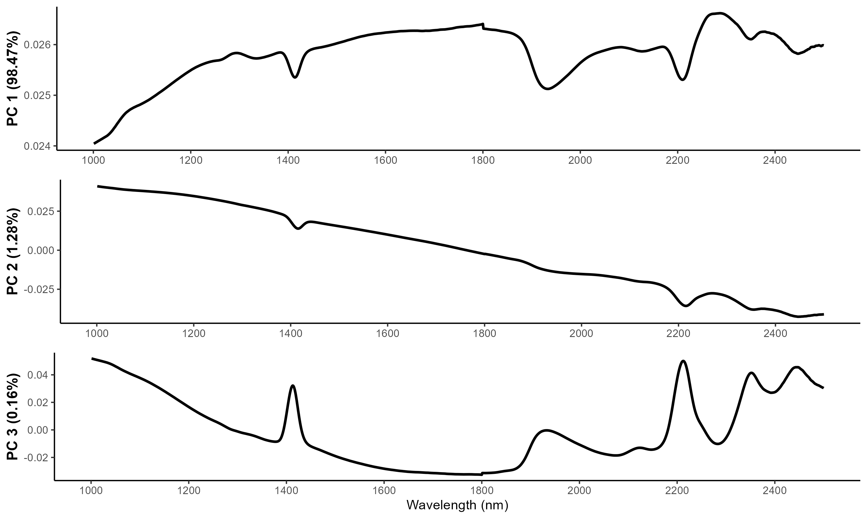

Figure 9.1: PCA loadings for the first 3 principal components for the NIR data.

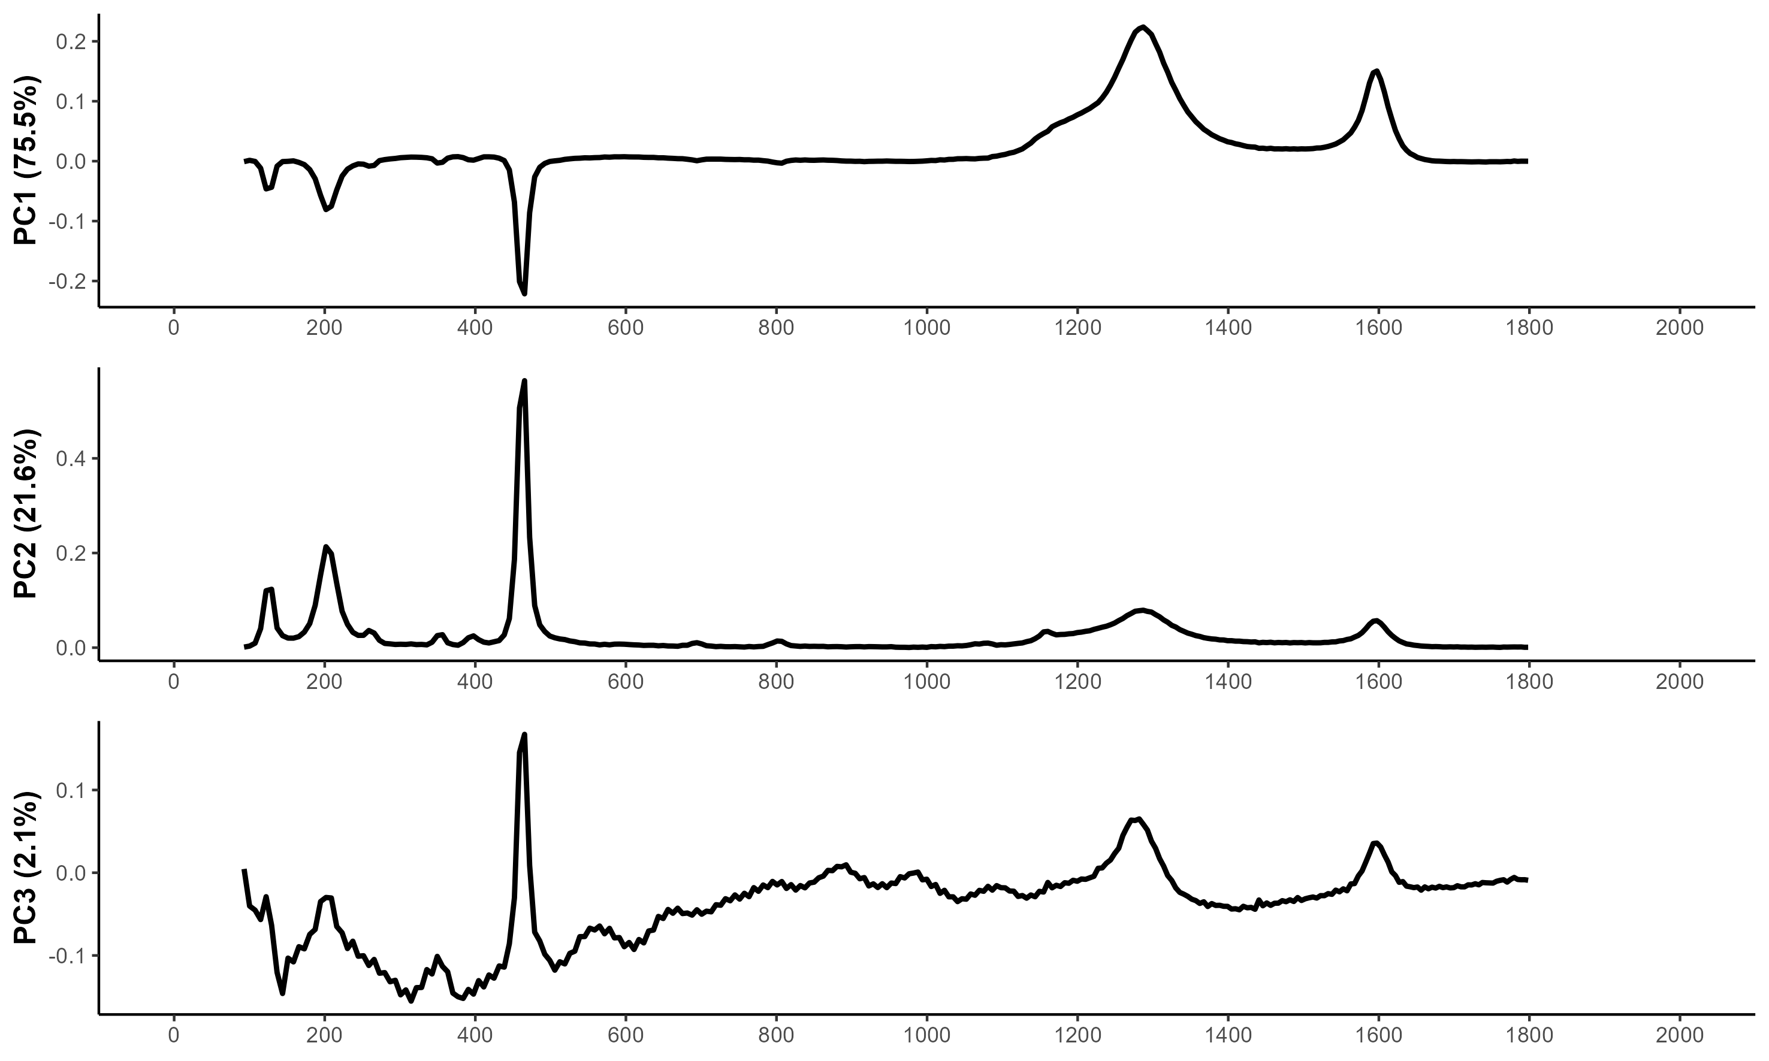

Figure 9.2: PCA loadings for the first 3 principal components for the Raman data

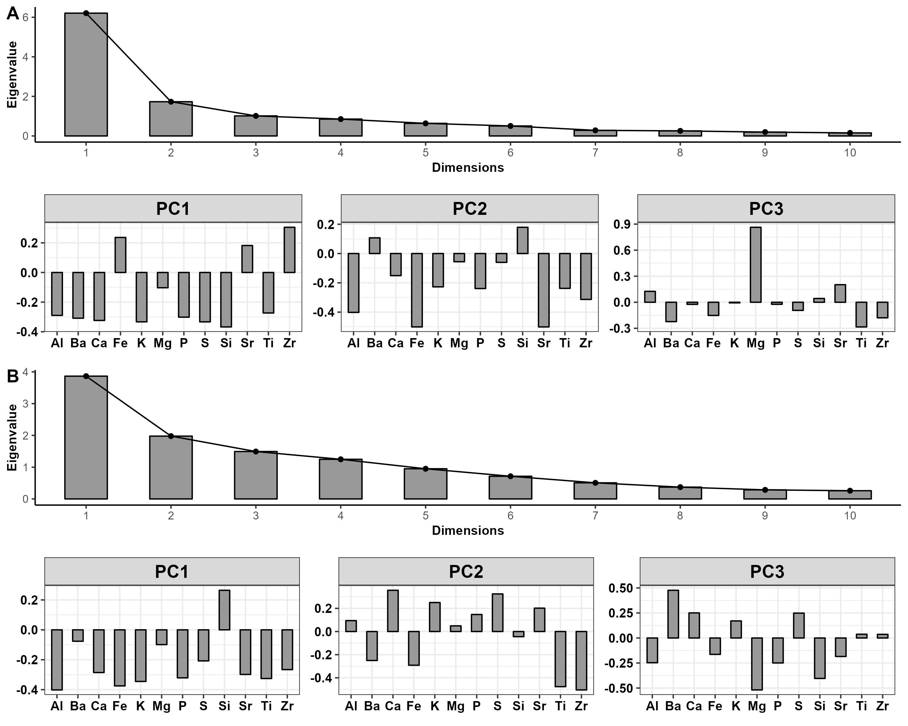

### 9.0.1 Colophon

This report was generated on 2023-01-05 15:30:53 using the following computational environment and dependencies:

#> ─ Session info ───────────────────────────────────────────────────────────────  
#> setting value  
#> version R version 4.2.2 (2022-10-31 ucrt)  
#> os Windows 10 x64 (build 19044)  
#> system x86_64, mingw32  
#> ui RTerm  
#> language (EN)  
#> collate Swedish_Sweden.utf8  
#> ctype Swedish_Sweden.utf8  
#> tz Europe/Berlin  
#> date 2023-01-05  
#> pandoc 2.19.2 @ C:/Program Files/RStudio/resources/app/bin/quarto/bin/tools/ (via rmarkdown)  
#>   
#> ─ Packages ───────────────────────────────────────────────────────────────────  
#> package * version date (UTC) lib source  
#> abind 1.4-5 2016-07-21 [1] CRAN (R 4.2.0)  
#> assertthat 0.2.1 2019-03-21 [1] CRAN (R 4.2.2)  
#> backports 1.4.1 2021-12-13 [2] CRAN (R 4.2.0)  
#> base64enc 0.1-3 2015-07-28 [2] CRAN (R 4.2.0)  
#> baseline 1.3-4 2022-07-06 [1] CRAN (R 4.2.2)  
#> bitops 1.0-7 2021-04-24 [2] CRAN (R 4.2.0)  
#> bookdown 0.30 2022-11-09 [1] CRAN (R 4.2.2)  
#> boot 1.3-28.1 2022-11-22 [1] CRAN (R 4.2.2)  
#> broom 1.0.1 2022-08-29 [2] CRAN (R 4.2.1)  
#> cachem 1.0.6 2021-08-19 [2] CRAN (R 4.2.1)  
#> callr 3.7.3 2022-11-02 [1] CRAN (R 4.2.2)  
#> car 3.1-1 2022-10-19 [1] CRAN (R 4.2.2)  
#> carData 3.0-5 2022-01-06 [1] CRAN (R 4.2.2)  
#> cellranger 1.1.0 2016-07-27 [1] CRAN (R 4.2.2)  
#> ChemoSpec * 6.1.4 2022-10-21 [1] CRAN (R 4.2.2)  
#> ChemoSpecUtils * 1.0.0 2021-10-10 [1] CRAN (R 4.2.2)  
#> class 7.3-20 2022-01-16 [2] CRAN (R 4.2.2)  
#> cli 3.4.1 2022-09-23 [1] CRAN (R 4.2.2)  
#> cluster 2.1.4 2022-08-22 [2] CRAN (R 4.2.2)  
#> codetools 0.2-18 2020-11-04 [2] CRAN (R 4.2.2)  
#> colorspace 2.0-3 2022-02-21 [2] CRAN (R 4.2.1)  
#> cowplot * 1.1.1 2020-12-30 [1] CRAN (R 4.2.2)  
#> crayon 1.5.2 2022-09-29 [1] CRAN (R 4.2.2)  
#> cvTools 0.3.2 2012-05-14 [1] CRAN (R 4.2.2)  
#> data.table * 1.14.4 2022-10-17 [1] CRAN (R 4.2.2)  
#> DBI 1.1.3 2022-06-18 [1] CRAN (R 4.2.2)  
#> dbplyr 2.2.1 2022-06-27 [1] CRAN (R 4.2.2)  
#> DEoptimR 1.0-11 2022-04-03 [1] CRAN (R 4.2.0)  
#> deSolve 1.34 2022-10-22 [1] CRAN (R 4.2.2)  
#> devtools 2.4.5 2022-10-11 [1] CRAN (R 4.2.2)  
#> digest 0.6.30 2022-10-18 [1] CRAN (R 4.2.2)  
#> diptest 0.76-0 2021-05-04 [1] CRAN (R 4.2.0)  
#> dplyr * 1.0.10 2022-09-01 [1] CRAN (R 4.2.2)  
#> e1071 1.7-12 2022-10-24 [1] CRAN (R 4.2.2)  
#> ellipsis 0.3.2 2021-04-29 [2] CRAN (R 4.2.1)  
#> evaluate 0.18 2022-11-07 [1] CRAN (R 4.2.2)  
#> factoextra * 1.0.7 2020-04-01 [1] CRAN (R 4.2.2)  
#> fansi 1.0.3 2022-03-24 [2] CRAN (R 4.2.1)  
#> farver 2.1.1 2022-07-06 [2] CRAN (R 4.2.1)  
#> fastmap 1.1.0 2021-01-25 [2] CRAN (R 4.2.1)  
#> fda 6.0.5 2022-07-04 [1] CRAN (R 4.2.2)  
#> fds 1.8 2018-10-31 [1] CRAN (R 4.2.2)  
#> flexmix 2.3-18 2022-06-07 [1] CRAN (R 4.2.2)  
#> flextable * 0.8.3 2022-11-06 [1] CRAN (R 4.2.2)  
#> forcats * 0.5.2 2022-08-19 [2] CRAN (R 4.2.1)  
#> foreach 1.5.2 2022-02-02 [1] CRAN (R 4.2.2)  
#> fpc 2.2-9 2020-12-06 [1] CRAN (R 4.2.2)  
#> fs 1.5.2 2021-12-08 [2] CRAN (R 4.2.1)  
#> gargle 1.2.1 2022-09-08 [1] CRAN (R 4.2.2)  
#> gdtools 0.2.4 2022-02-14 [1] CRAN (R 4.2.2)  
#> generics 0.1.3 2022-07-05 [2] CRAN (R 4.2.1)  
#> GGally 2.1.2 2021-06-21 [1] CRAN (R 4.2.2)  
#> ggfortify 0.4.15 2022-11-11 [1] CRAN (R 4.2.2)  
#> ggplot2 * 3.4.0 2022-11-04 [1] CRAN (R 4.2.2)  
#> ggpubr * 0.5.0 2022-11-16 [1] CRAN (R 4.2.2)  
#> ggrepel 0.9.2 2022-11-06 [1] CRAN (R 4.2.2)  
#> ggsignif 0.6.4 2022-10-13 [1] CRAN (R 4.2.2)  
#> glue 1.6.2 2022-02-24 [2] CRAN (R 4.2.1)  
#> googledrive 2.0.0 2021-07-08 [1] CRAN (R 4.2.2)  
#> googlesheets4 1.0.1 2022-08-13 [1] CRAN (R 4.2.2)  
#> gridBase * 0.4-7 2014-02-24 [1] CRAN (R 4.2.2)  
#> gridExtra 2.3 2017-09-09 [1] CRAN (R 4.2.2)  
#> gtable 0.3.1 2022-09-01 [2] CRAN (R 4.2.1)  
#> haven 2.5.1 2022-08-22 [1] CRAN (R 4.2.2)  
#> hdrcde 3.4 2021-01-18 [1] CRAN (R 4.2.2)  
#> here 1.0.1 2020-12-13 [1] CRAN (R 4.2.2)  
#> highr 0.9 2021-04-16 [2] CRAN (R 4.2.1)  
#> hms 1.1.2 2022-08-19 [1] CRAN (R 4.2.2)  
#> htmltools 0.5.3 2022-07-18 [2] CRAN (R 4.2.1)  
#> htmlwidgets 1.5.4 2021-09-08 [2] CRAN (R 4.2.1)  
#> httpuv 1.6.6 2022-09-08 [1] CRAN (R 4.2.2)  
#> httr 1.4.4 2022-08-17 [2] CRAN (R 4.2.1)  
#> iterators 1.0.14 2022-02-05 [1] CRAN (R 4.2.2)  
#> jpeg 0.1-10 2022-11-29 [1] CRAN (R 4.2.2)  
#> jsonlite 1.8.3 2022-10-21 [1] CRAN (R 4.2.2)  
#> kernlab 0.9-31 2022-06-09 [1] CRAN (R 4.2.0)  
#> KernSmooth 2.23-20 2021-05-03 [2] CRAN (R 4.2.2)  
#> knitr 1.40 2022-08-24 [2] CRAN (R 4.2.1)  
#> ks 1.13.5 2022-04-14 [1] CRAN (R 4.2.2)  
#> labeling 0.4.2 2020-10-20 [2] CRAN (R 4.2.0)  
#> laeken 0.5.2 2021-10-06 [1] CRAN (R 4.2.2)  
#> later 1.3.0 2021-08-18 [2] CRAN (R 4.2.1)  
#> lattice 0.20-45 2021-09-22 [2] CRAN (R 4.2.2)  
#> lazyeval 0.2.2 2019-03-15 [1] CRAN (R 4.2.2)  
#> lifecycle 1.0.3 2022-10-07 [1] CRAN (R 4.2.2)  
#> limSolve 1.5.6 2019-11-14 [1] CRAN (R 4.2.2)  
#> lmtest 0.9-40 2022-03-21 [1] CRAN (R 4.2.2)  
#> loder * 0.2.0 2018-06-15 [1] CRAN (R 4.2.2)  
#> lpSolve 5.6.17 2022-10-10 [1] CRAN (R 4.2.1)  
#> lubridate 1.9.0 2022-11-06 [1] CRAN (R 4.2.2)  
#> magrittr 2.0.3 2022-03-30 [2] CRAN (R 4.2.1)  
#> MASS 7.3-58.1 2022-08-03 [2] CRAN (R 4.2.2)  
#> mathjaxr 1.6-0 2022-02-28 [1] CRAN (R 4.2.2)  
#> Matrix 1.5-3 2022-11-11 [1] CRAN (R 4.2.2)  
#> mclust 6.0.0 2022-10-31 [1] CRAN (R 4.2.2)  
#> memoise 2.0.1 2021-11-26 [2] CRAN (R 4.2.1)  
#> mime 0.12 2021-09-28 [2] CRAN (R 4.2.0)  
#> miniUI 0.1.1.1 2018-05-18 [2] CRAN (R 4.2.1)  
#> modelr 0.1.10 2022-11-11 [1] CRAN (R 4.2.2)  
#> modeltools 0.2-23 2020-03-05 [1] CRAN (R 4.2.0)  
#> munsell 0.5.0 2018-06-12 [2] CRAN (R 4.2.1)  
#> mvtnorm 1.1-3 2021-10-08 [1] CRAN (R 4.2.0)  
#> NADA 1.6-1.1 2020-03-22 [1] CRAN (R 4.2.2)  
#> nnet 7.3-18 2022-09-28 [2] CRAN (R 4.2.2)  
#> officer 0.4.4 2022-09-09 [1] CRAN (R 4.2.2)  
#> patchwork 1.1.2 2022-08-19 [1] CRAN (R 4.2.2)  
#> pcaPP 2.0-3 2022-10-24 [1] CRAN (R 4.2.2)  
#> perry 0.3.1 2021-11-03 [1] CRAN (R 4.2.2)  
#> pillar 1.8.1 2022-08-19 [2] CRAN (R 4.2.1)  
#> pkgbuild 1.3.1 2021-12-20 [2] CRAN (R 4.2.1)  
#> pkgconfig 2.0.3 2019-09-22 [2] CRAN (R 4.2.1)  
#> pkgload 1.3.2 2022-11-16 [1] CRAN (R 4.2.2)  
#> plotly * 4.10.1 2022-11-07 [1] CRAN (R 4.2.2)  
#> pls * 2.8-1 2022-07-16 [1] CRAN (R 4.2.2)  
#> plyr 1.8.8 2022-11-11 [1] CRAN (R 4.2.2)  
#> png * 0.1-7 2013-12-03 [1] CRAN (R 4.2.0)  
#> prabclus 2.3-2 2020-01-08 [1] CRAN (R 4.2.2)  
#> pracma 2.4.2 2022-09-22 [1] CRAN (R 4.2.2)  
#> prettyunits 1.1.1 2020-01-24 [2] CRAN (R 4.2.1)  
#> processx 3.8.0 2022-10-26 [1] CRAN (R 4.2.2)  
#> profvis 0.3.7 2020-11-02 [2] CRAN (R 4.2.1)  
#> promises 1.2.0.1 2021-02-11 [2] CRAN (R 4.2.1)  
#> prospectr * 0.2.6 2022-08-31 [1] CRAN (R 4.2.2)  
#> proxy 0.4-27 2022-06-09 [1] CRAN (R 4.2.2)  
#> ps 1.7.2 2022-10-26 [1] CRAN (R 4.2.2)  
#> purrr * 0.3.5 2022-10-06 [1] CRAN (R 4.2.2)  
#> quadprog 1.5-8 2019-11-20 [1] CRAN (R 4.2.0)  
#> R.methodsS3 1.8.2 2022-06-13 [1] CRAN (R 4.2.0)  
#> R.oo 1.25.0 2022-06-12 [1] CRAN (R 4.2.0)  
#> R.utils 2.12.2 2022-11-11 [1] CRAN (R 4.2.2)  
#> R6 2.5.1 2021-08-19 [2] CRAN (R 4.2.1)  
#> ragg 1.2.4 2022-10-24 [1] CRAN (R 4.2.2)  
#> rainbow 3.7 2022-10-09 [1] CRAN (R 4.2.2)  
#> ranger 0.14.1 2022-06-18 [1] CRAN (R 4.2.2)  
#> RColorBrewer 1.1-3 2022-04-03 [2] CRAN (R 4.2.0)  
#> Rcpp 1.0.9 2022-07-08 [2] CRAN (R 4.2.1)  
#> RCurl 1.98-1.9 2022-10-03 [1] CRAN (R 4.2.1)  
#> readJDX 0.6.1 2021-09-20 [1] CRAN (R 4.2.2)  
#> readr * 2.1.3 2022-10-01 [1] CRAN (R 4.2.2)  
#> readxl 1.4.1 2022-08-17 [1] CRAN (R 4.2.2)  
#> remotes 2.4.2 2021-11-30 [2] CRAN (R 4.2.1)  
#> reprex 2.0.2 2022-08-17 [1] CRAN (R 4.2.2)  
#> reshape 0.8.9 2022-04-12 [1] CRAN (R 4.2.2)  
#> reshape2 * 1.4.4 2020-04-09 [1] CRAN (R 4.2.2)  
#> rlang 1.0.6 2022-09-24 [1] CRAN (R 4.2.2)  
#> rmarkdown 2.18 2022-11-09 [1] CRAN (R 4.2.2)  
#> robCompositions * 2.3.1 2021-09-20 [1] CRAN (R 4.2.2)  
#> robustbase 0.95-0 2022-04-02 [1] CRAN (R 4.2.2)  
#> robustHD 0.7.3 2022-08-12 [1] CRAN (R 4.2.2)  
#> rprojroot 2.0.3 2022-04-02 [2] CRAN (R 4.2.1)  
#> rrcov 1.7-2 2022-10-24 [1] CRAN (R 4.2.2)  
#> rstatix 0.7.1 2022-11-09 [1] CRAN (R 4.2.2)  
#> rstudioapi 0.14 2022-08-22 [2] CRAN (R 4.2.1)  
#> rvest 1.0.3 2022-08-19 [1] CRAN (R 4.2.2)  
#> scales 1.2.1 2022-08-20 [2] CRAN (R 4.2.1)  
#> sessioninfo 1.2.2 2021-12-06 [2] CRAN (R 4.2.1)  
#> shiny 1.7.3 2022-10-25 [1] CRAN (R 4.2.2)  
#> shinyjs 2.1.0 2021-12-23 [1] CRAN (R 4.2.2)  
#> sp 1.5-1 2022-11-07 [1] CRAN (R 4.2.2)  
#> SparseM 1.81 2021-02-18 [1] CRAN (R 4.2.0)  
#> spectrolab * 0.0.17 2022-07-14 [1] CRAN (R 4.2.2)  
#> stringi 1.7.8 2022-07-11 [2] CRAN (R 4.2.1)  
#> stringr * 1.4.1 2022-08-20 [2] CRAN (R 4.2.1)  
#> survival 3.4-0 2022-08-09 [2] CRAN (R 4.2.2)  
#> systemfonts 1.0.4 2022-02-11 [2] CRAN (R 4.2.1)  
#> textshaping 0.3.6 2021-10-13 [2] CRAN (R 4.2.1)  
#> tibble * 3.1.8 2022-07-22 [2] CRAN (R 4.2.1)  
#> tidyr * 1.2.1 2022-09-08 [1] CRAN (R 4.2.2)  
#> tidyselect 1.2.0 2022-10-10 [1] CRAN (R 4.2.2)  
#> tidyverse * 1.3.2 2022-07-18 [1] CRAN (R 4.2.2)  
#> timechange 0.1.1 2022-11-04 [1] CRAN (R 4.2.2)  
#> truncnorm 1.0-8 2018-02-27 [1] CRAN (R 4.2.2)  
#> tzdb 0.3.0 2022-03-28 [1] CRAN (R 4.2.2)  
#> urlchecker 1.0.1 2021-11-30 [2] CRAN (R 4.2.1)  
#> usethis 2.1.6 2022-05-25 [2] CRAN (R 4.2.1)  
#> utf8 1.2.2 2021-07-24 [2] CRAN (R 4.2.1)  
#> uuid 1.1-0 2022-04-19 [1] CRAN (R 4.2.0)  
#> vcd 1.4-10 2022-06-09 [1] CRAN (R 4.2.2)  
#> vctrs 0.5.0 2022-10-22 [1] CRAN (R 4.2.2)  
#> VIM 6.2.2 2022-08-25 [1] CRAN (R 4.2.2)  
#> viridisLite 0.4.1 2022-08-22 [2] CRAN (R 4.2.1)  
#> withr 2.5.0 2022-03-03 [2] CRAN (R 4.2.1)  
#> xfun 0.32 2022-08-10 [2] CRAN (R 4.2.1)  
#> xml2 1.3.3 2021-11-30 [2] CRAN (R 4.2.1)  
#> xtable 1.8-4 2019-04-21 [2] CRAN (R 4.2.1)  
#> yaml 2.3.6 2022-10-18 [1] CRAN (R 4.2.1)  
#> zCompositions 1.4.0-1 2022-03-26 [1] CRAN (R 4.2.2)  
#> zip 2.2.2 2022-10-26 [1] CRAN (R 4.2.2)  
#> zoo 1.8-11 2022-09-17 [1] CRAN (R 4.2.2)  
#>   
#> [1] C:/Users/masj0062/AppData/Local/R/win-library/4.2  
#> [2] C:/Program Files/R/R-4.2.2/library  
#>   
#> ──────────────────────────────────────────────────────────────────────────────

The current Git commit details are:

#> Local: main C:/Users/masj0062/Documents/VERSION CONTROL/quantifying-quartzite  
#> Remote: main @ origin (https://github.com/MattiasSealander/quantifying-quartzite.git)  
#> Head: [bf24387] 2023-01-04: Updated figure name

1. This is not to say that flint was not available or used in these regions
2. For comparison, Mjærum (2012) has put forth a chronology for bifacial points in southwestern Norway
3. www.umu.se/en/research/infrastructure/mal/
4. Raman shifts are typically given in wavenumber (cm-1), instead of spectral wavelength (nm)
5. www.slu.se/en/departments/forest-biomaterials-technology/